

CAPSTONE PROJECT REPORT
Report 4 – Software Design Document

Automatic Brewing Coffee

– Ho Chi Minh, April 2025 –

Table of Contents
I. Record of Changes 3
II. Software Design Document 4
1. System Design 4
1.1 System Architecture 4
1.2 Package Diagram 5
2. Database Design 9
2.1. Logical ERD 9
2.2. Physical ERD 9
3. Detailed Design 9
3.1 Login 9
3.2 Login Admin 11
3.3 Refresh Token 13
3.4 Create Organization 14
3.5 Create Kiosk 16
3.6 Create Device Model 17
3.7 Create Device 19
3.8 Create Order 21
3.9 Process Order 23
3.10 Synchronous Kiosk Data 25

I. Record of Changes
Date | A*  M, D | In charge | Change Description
*A - Added M - Modified D - Deleted

II. Software Design Document

1. System Design

1.1 System Architecture

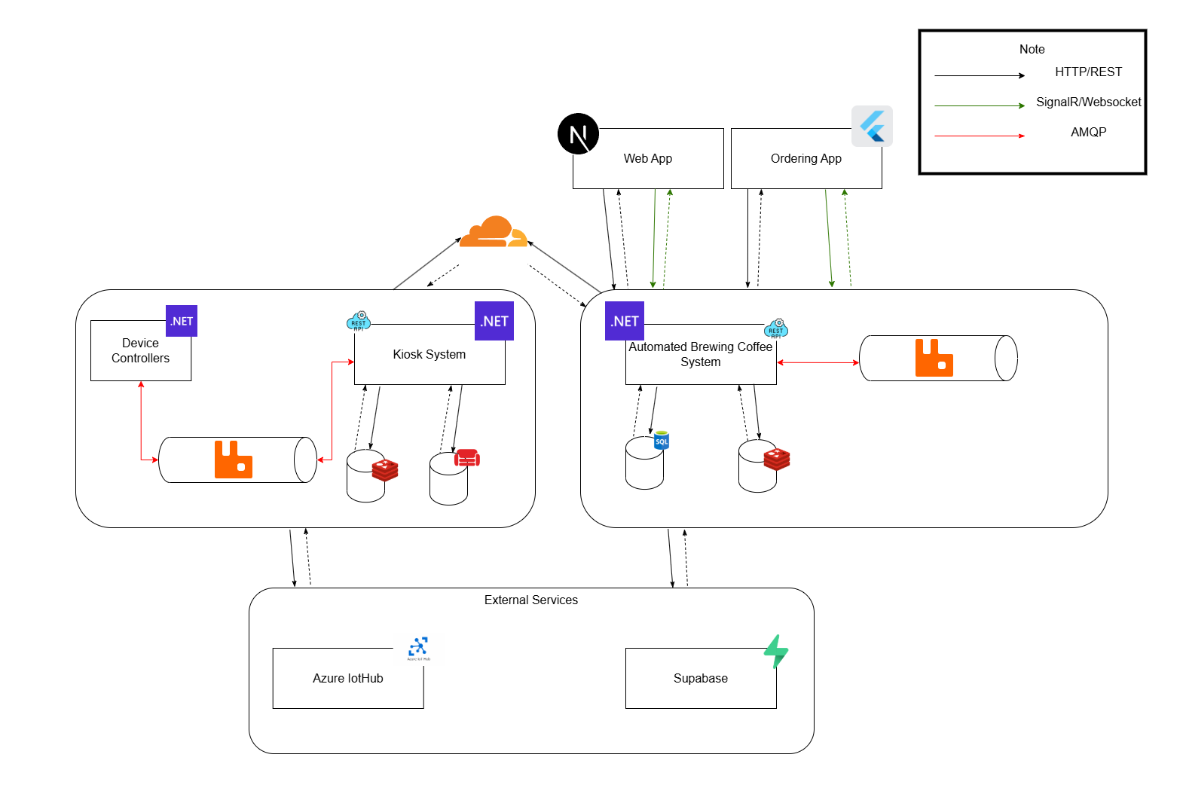

1.2 Package Diagram

1.2.1 Kiosk Package Diagram
Figure 1.2.1 Kiosk package diagram
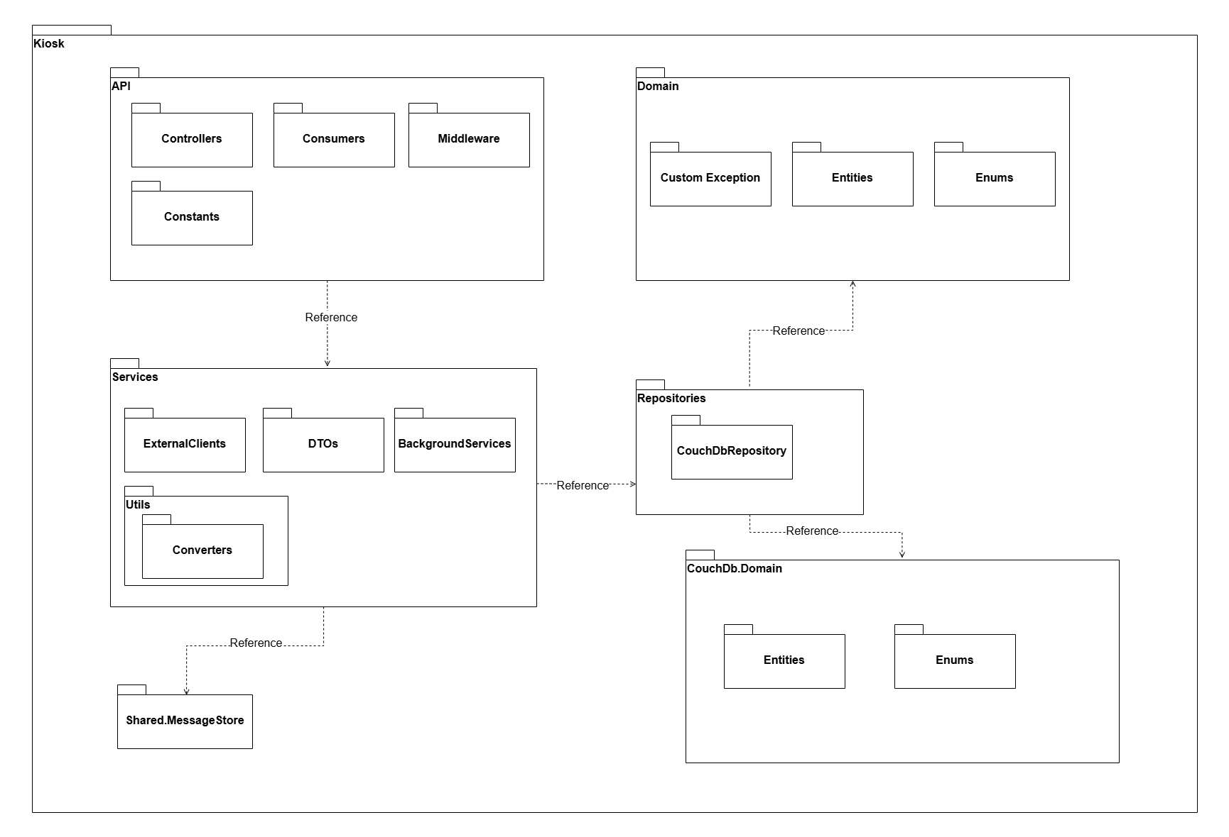

1.2.1.1 Package Description

No | Package | Description
01 | API | Exposes endpoints, contains middleware, helpers, real-time hubs, and services.
02 | CouchDb.Domain | Defines CouchDB entities, enums.
03 | Domain | Defines core business entities, enums, and exceptions.
04 | Repositories | Contains CouchDB repositories
05 | Services | Business logic layer, including interfaces, implementations.
06 | Controllers | Handles HTTP requests and routes to services.
07 | Consumers | Contains consumer classes responding to messages from RabbitMQ.
08 | Middlewares | Pipeline components for request/response handling.
09 | Constants | Define shared constants for API endpoints, header keys used across controllers.
10 | ExternalClients | Contains HTTP client classes responsible for handling communication with external cloud systems.
11 | DTOs | Contains all data transfer objects used in the system
12 | BackgroundServices | Contains host background services that monitor and react to changes in CouchDB, enabling asynchronous and publish message events..
13 | Utils | Utility functions to support operations.
14 | Converters | Contains classes for transforming input data into desired output formats.
15 | Enums | Enumerations representing fixed value sets.
16 | CustomExceptions | Defines system error models and error codes.
17 | Shared.MessageStore | Defines system event messages, exchange names, queue names, and routing keys for each queue used in message-based communication.

1.2.2 Automated Brewing Coffee Package Diagram
Figure 1.2.2 Automated Brewing Coffee Package Diagram
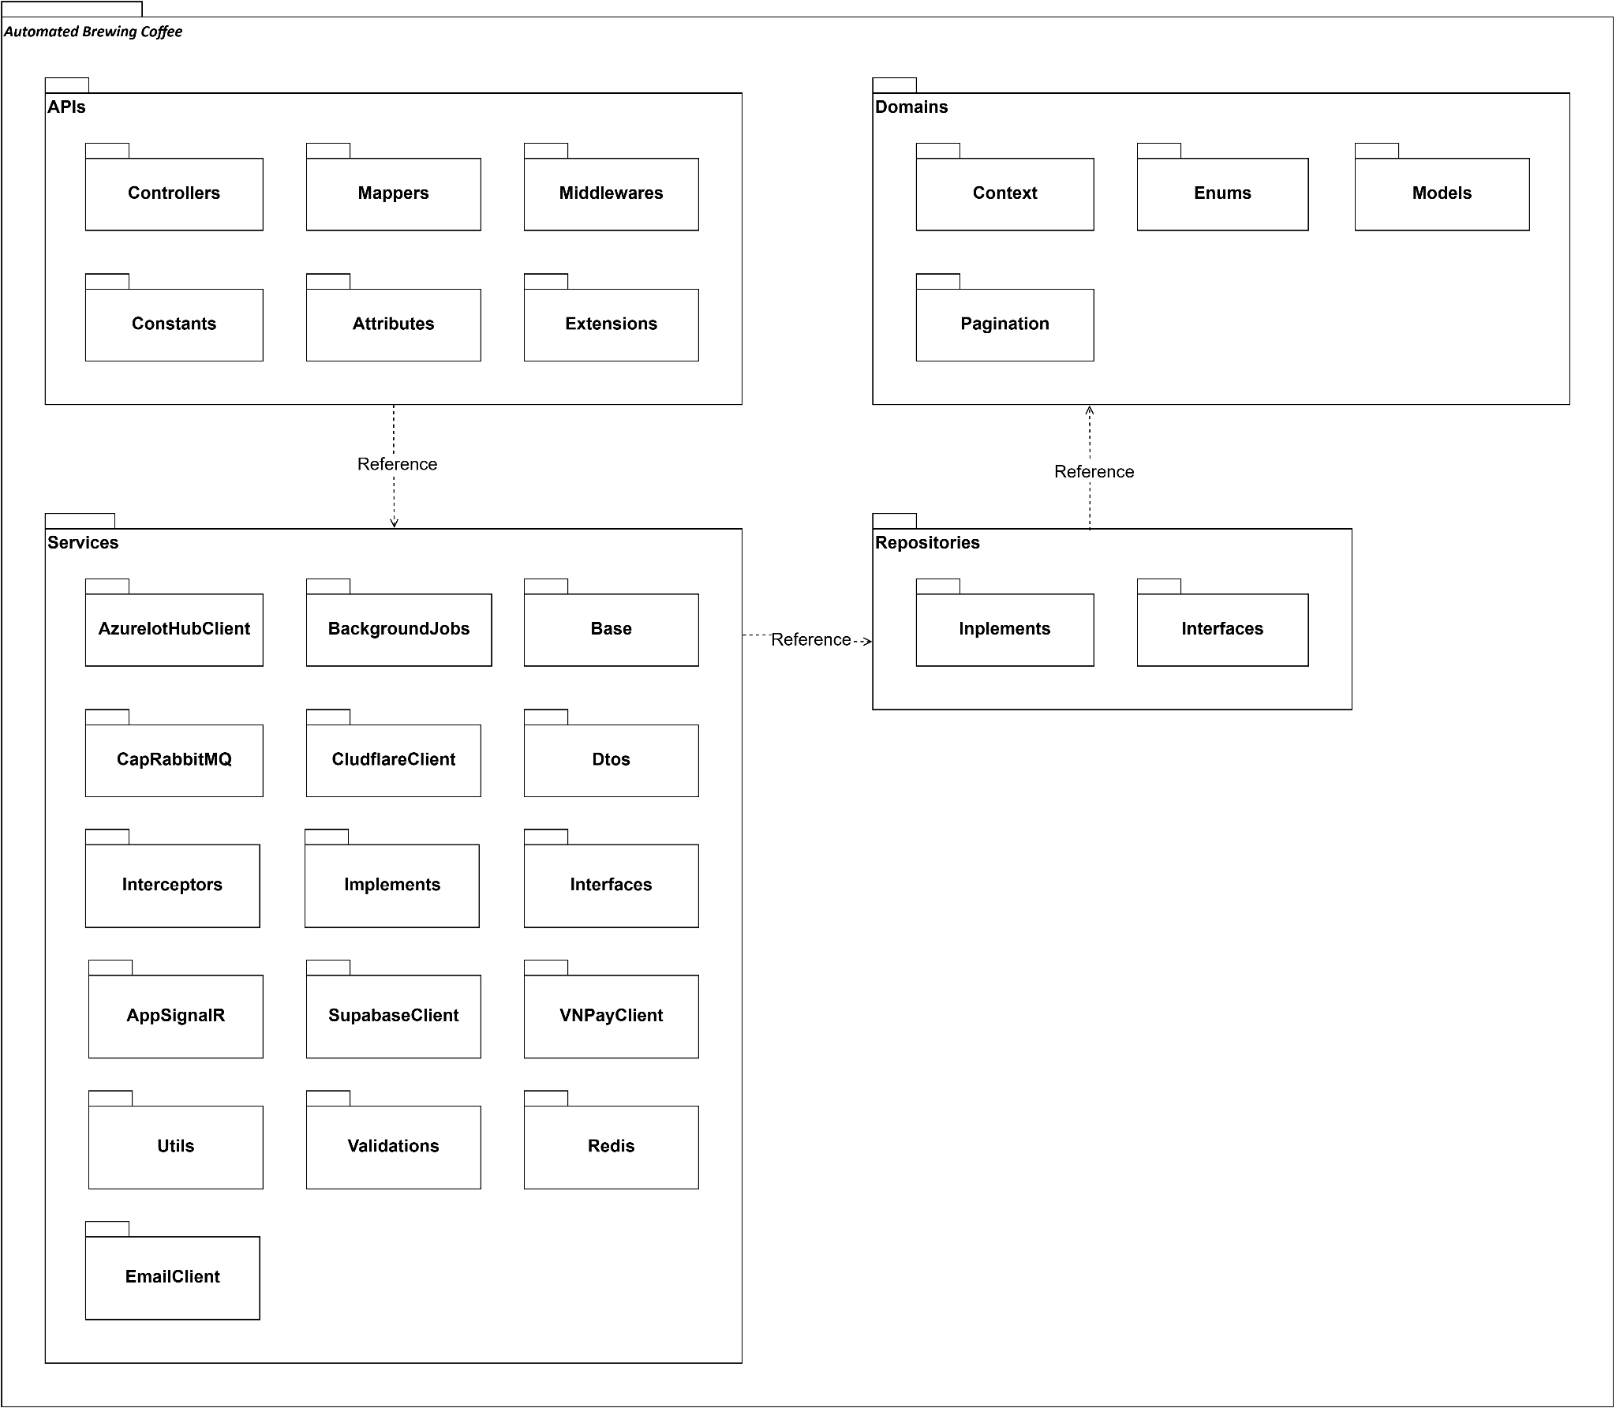

1.2.2.1 Package Description

No | Package | Description
1 | APIs | Contains all HTTP-facing components such as controllers, mappers, middlewares, and utility extensions.
2 | APIs.Controllers | Defines REST API endpoints that handle incoming HTTP requests.
3 | APIs.Mappers | Define mapping rules between entities and DTOs (Data Transfer Objects).
4 | APIs.Middlewares | Includes middlewares for the system.
5 | APIs.Constants | Defines reusable system-wide constants.
6 | APIs.Attributes | Custom attributes for validation, authorization, and metadata.
7 | APIs.Extensions | Extension methods to support controller logic or service registration.
8 | Domains | Represents the core domain logic including entities, enums, and DbContext.
9 | Domains.Context | Contains the DbContext and EF Core configurations.
10 | Domains.Enums | Defines all enum types used across the system).
11 | Domains.Models | Entity classes that represent tables in the database.
12 | Domains.Pagination | Includes pagination-related models and helpers.
13 | Repositories | Data Access Layer that defines and implements data queries and persistence.
14 | Repositories.Interfaces | Repository interfaces for entity access.
15 | Repositories.Implements | Concrete implementations of repository interfaces.
16 | Services | Contains business logic services and integrations with external/internal systems.
17 | Services.AzureIotHubClient | Handles communication with Azure IoT Hub for device control and updates.
18 | Services.BackgroundJobs | Background job handlers using Hangfire (e.g. syncing, device checks).
19 | Services.Base | Common base classes shared by services.
20 | Services.CapRabbitMQ | Integration with RabbitMQ using CAP for event publishing and subscribing.
21 | Services.CloudflareClient | Cloudflare integration services (e.g. purge cache, signed URLs).
22 | Services.Dtos | DTO classes used to exchange data between layers.
23 | Services.Interceptors | HTTP/gRPC interceptors for logging, retry, or performance monitoring.
24 | Services.Implements | Business logic implementations of service interfaces.
25 | Services.Interfaces | Interfaces that define service contracts.
26 | Services.AppSignalR | Real-time communication using SignalR for push notifications to clients.
27 | Services.SupabaseClient | Supabase integration for authentication or data storage.
28 | Services.VNPayClient | VNPay payment integration
29 | Services.Utils | Common utilities and helpers used across services.
30 | Services.Validations | Input validation logic for DTOs and custom business rules.
31 | Services.Redis | Redis configuration and caching/locking logic.
32 | Services.EmailClient | Email sending client.

1.2.3 Ordering App Package Diagram
Figure 1.2.3 Ordering App package diagram
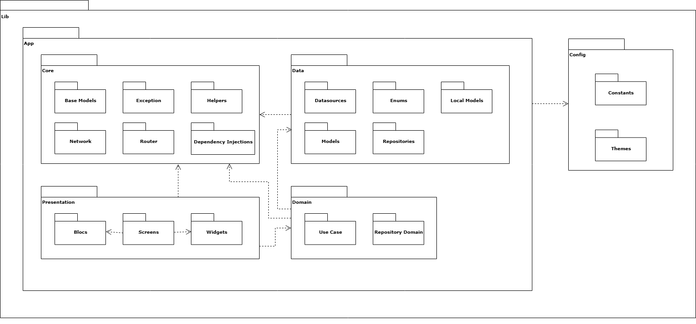

1.2.3.1 Package Description
1.2.3.1 Flutter BLoC Project Structure Descriptions
No | Package | Description
01 | Lib | Root directory for all Flutter code in the application
02 | Config | Holds static configuration files and resources that are used across the application
03 | App | Contains all the core logic and features of the application, structured into distinct layers

1.2.3.2 Config Layer Descriptions
1.2.3.2 Config Layer Descriptions
No | Package | Description
01 | Constants | A centralized repository for all constant values used throughout the application
02 | Theme | Defines the visual styling and themes for the application's user interface

1.2.3.3 App Layer Descriptions
1.2.3.3 App Layer Descriptions
No | Package | Description
01 | Core | Shared services, utilities, and base classes used across the entire application. It supports all other layers
02 | Data | Data layer handling API interactions and local storage
03 | Domain | Enterprise-wide business rules and is completely independent of any UI, database, or network implementation details
04 | Presentation | Presentation layer with UI components and BLoC implementations. It is what the user sees and interacts with

1.2.3.4 Core Layer Descriptions
1.2.3.4 Core Layer Descriptions
No | Package | Description
01 | Base Models | Abstract base classes for models to reduce code duplication
02 | Exception | Custom exception classes for the application
03 | Helpers | A collection of stateless utility functions and extension methods
04 | Network | Network-related configurations
05 | Router | Navigation and routing for the application
06 | Dependency Injections | It configures the dependency injection container

1.2.3.5 Data Layer Descriptions
1.2.3.5 Data Layer Descriptions
No | Package | Description
01 | Datasources | The actual source of data. This is typically split into remote and local datasources
02 | Enums | Enumeration definitions
03 | Local Models | Structure of the local database, if it differs from the remote API models
04 | Models | These are Data Transfer Objects that represent the structure of data coming from a specific source
05 | Repositories | Concrete implementations of the Repository Domain interfaces

1.2.3.6 Domain Layer Descriptions
1.2.3.6 Domain Layer Descriptions
No | Package | Description
01 | Use Case | Single, specific business action or user story
02 | Repository Domain | Defines the abstract contracts (interfaces) for the data layer

1.2.3.7 Presentation Layer Descriptions
1.2.3.7 Presentation Layer Descriptions
No | Package | Description
01 | Screens | Individual screens of the application
02 | Widgets | Smaller, reusable UI components that can be shared across multiple Screens
03 | Blocs | The state management logic for the UI

1.2.4 Web App Package Diagram

Figure 1.2.4 Web App package diagram

1.2.4.1 App Routing Description

No | Package | Description
01 | app | The main application folder contains routes and pages. It includes two main areas: auth (Login page) and admin, which contains sub-modules such as device management, kiosk management, workflow management, sync management, and others. Each module contains related pages for performing CRUD operations and configurations.
02 | components | A shared library containing reusable UI components grouped by domain (e.g., Auth components, Device components, Workflow components, etc.). It also includes shared components such as Form components, Dialog components, Layout components, and Common components.
03 | hooks | Contains custom React hooks used across the application for encapsulating reusable logic, such as data fetching, form handling, and state management.
04 | store | Contains Zustand stores for managing global state across the application, such as user info, shared filters, or UI states.
05 | context | Contains context providers that use React's Context API to manage scoped data like user authentication context, theme settings, or permissions.
06 | service | Contains service modules for handling API calls, usually implemented using axios. These modules abstract the communication between the frontend and the backend.
07 | schema | Holds TypeScript interfaces and schemas to define and validate shared data models used throughout the application.

1.2.4.2 Components Package Description

No | Package | Description
01 | auth | Contains UI components related to authentication flows such as login forms, password fields, and validation messages.
02 | manage-devices | Components for managing device-related entities like device types, models, and detailed device forms
03 | manage-kiosks | UI components for handling kiosk-related features, such as kiosk type forms and version management interfaces.
04 | manage-workflows | Contains reusable components for creating, updating, and managing workflows. Includes task editors, status selectors, and timeline views.
05 | dialog | Generic dialog or modal components used across the app. Examples include confirmation modals, form dialogs, and information popups.
06 | manage-menus | Components for managing menu items and categories, typically used in applications with ordering features.
07 | manage-syncs | Components for handling data synchronization tasks, sync task logs, schedules, and sync event views.
08 | manage-accounts | Contains UI for account management including profile forms, permission editors, and role selection interfaces.
09 | manage-locations | Components for defining and managing physical locations, such as location pickers, region selectors, and location forms.
10 | manage-orders | UI components for displaying and managing order data such as order details, status tracking, and order item views.
11 | manage-organizations | Components for managing organization information, including company data forms, org unit trees, and permission settings.
12 | manage-products | UI components for managing products: product cards, product form fields, pricing inputs, and inventory-related views.
13 | form | Generic form input components used across all domains, such as text fields, date pickers, toggles, dropdowns, and validation helpers.
14 | common | Shared components that are not domain-specific, including buttons, loading spinners, tags, icons, and typography elements.
15 | layout | Layout-related components such as headers, sidebars, navigation menus, breadcrumbs, and layout wrappers.
16 | manage-stores | UI components for managing store-specific configurations, store listing pages, detail forms, and status indicators.

1.2.4.3 Lib Package Description

No | Package | Description
01 | axios | Provides a centralized configuration of the axios HTTP client. This includes base URL setup, request/response interceptors, token injection (e.g., access token from localStorage), and unified error handling logic. It serves as the foundation for all API communication.
02 | swr | A shared library containing reusable UI components grouped by domain (e.g., Auth components, Device components, Workflow components, etc.). It also includes shared components such as Form components, Dialog components, Layout components, and Common components.
03 | utils | A collection of utility functions and helpers used across the application. These may include formatters (e.g., date, currency), deep clone methods, string manipulation, validation helpers, and other pure functions that increase code reuse and maintainability.

2. Database Design

2.1. Logical ERD

2.1.1 Automated Brewing Coffee Logical ERD
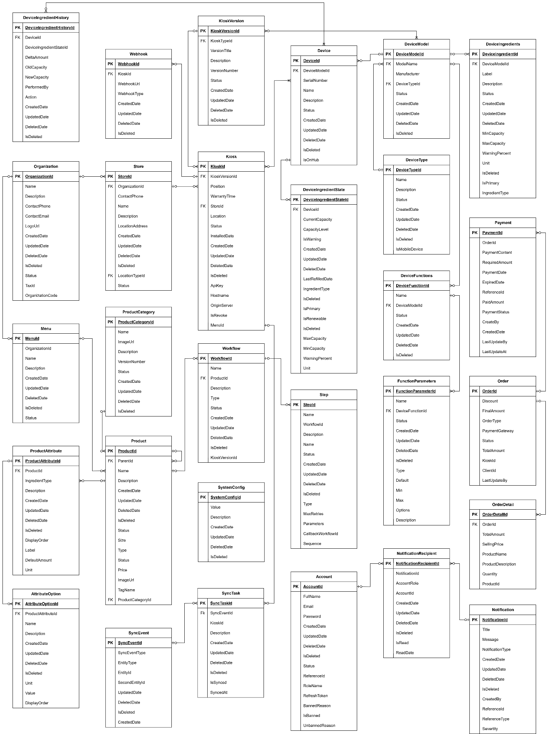

2.2. Physical ERD

2.2.1 Automated Brewing Coffee Physical ERD
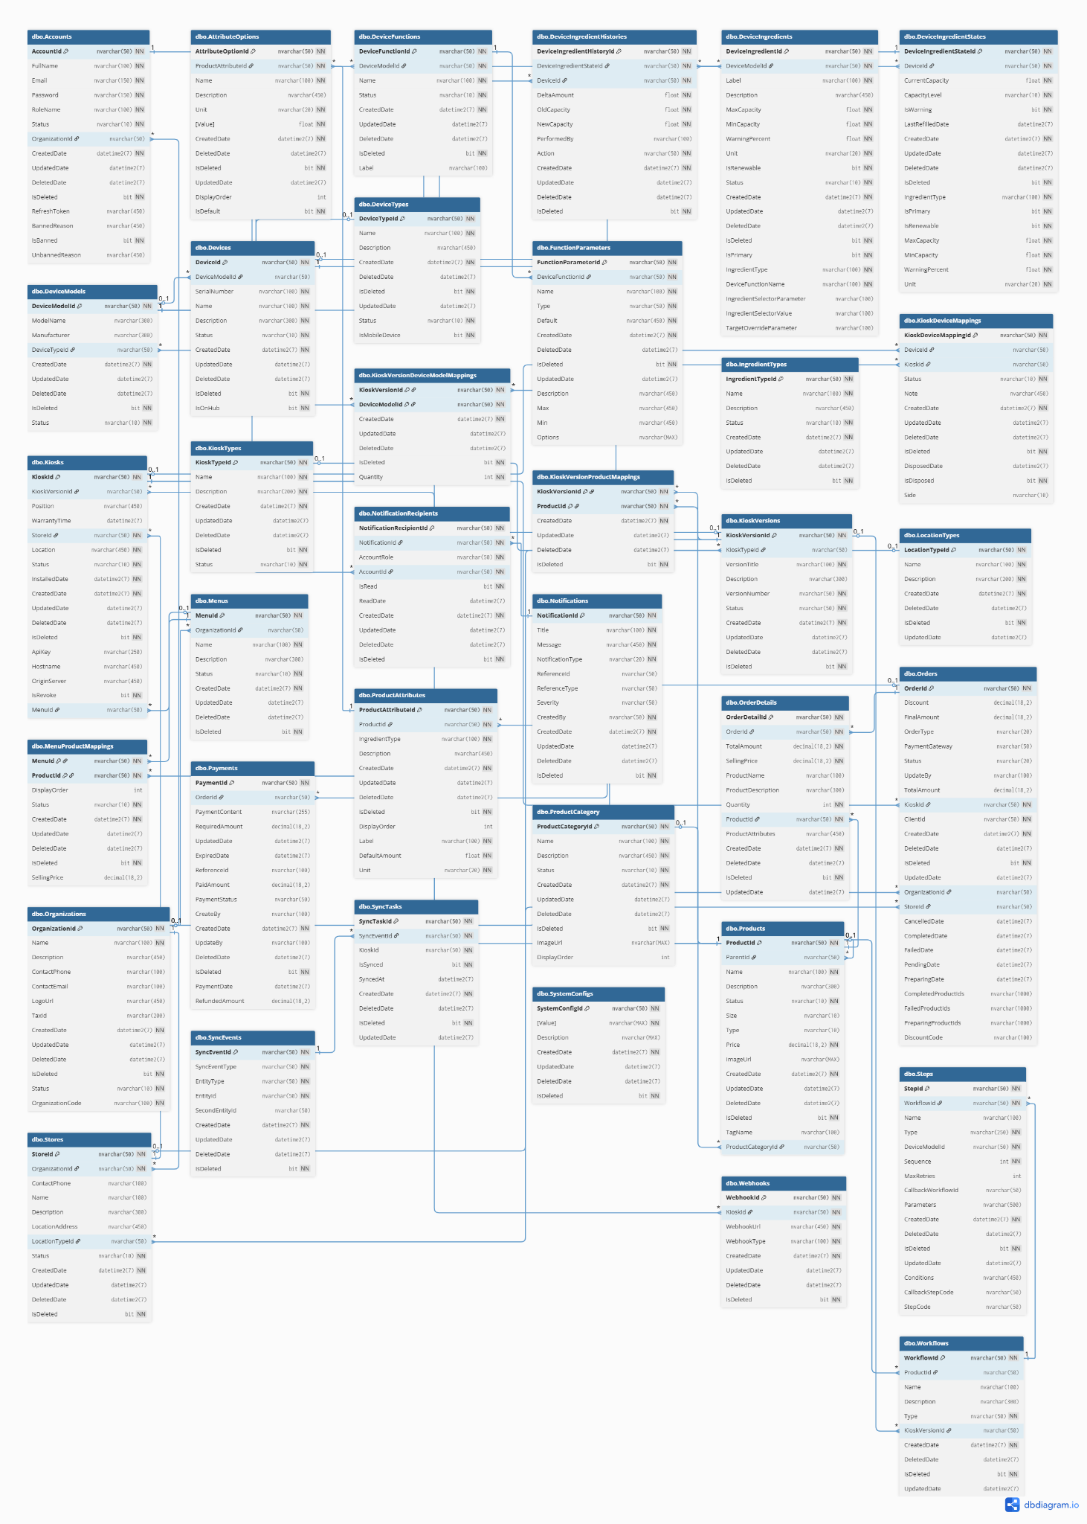

Table Descriptions
No | Table | Description
01 | Accounts | Stores user account information (login, role, status, token, ban/unban). - Primary keys: AccountId - Foreign keys: OrganizationId → Organizations.OrganizationId
02 | Organizations | Contains information about organizations (companies using the system). - Primary keys: OrganizationId - Foreign keys: (none)
03 | Stores | Represents stores belonging to an organization. - Primary keys: StoreId - Foreign keys: OrganizationId → Organizations.OrganizationId, LocationTypeId → LocationTypes.LocationTypeId
04 | Kiosks | Represents coffee kiosks installed at stores. - Primary keys: KioskId - Foreign keys: KioskVersionId → KioskVersions.KioskVersionId, StoreId → Stores.StoreId
05 | KioskTypes | Defines kiosk type categories. - Primary keys: KioskTypeId - Foreign keys: (none)
06 | KioskVersions | Version information of kiosks. - Primary keys: KioskVersionId - Foreign keys: KioskTypeId → KioskTypes.KioskTypeId
07 | KioskDeviceMappings | Mapping between kiosks and devices. - Primary keys: KioskDeviceMappingId - Foreign keys: DeviceId → Devices.DeviceId, KioskId → Kiosks.KioskId
08 | Devices | Represents a physical device inside a kiosk. - Primary keys: DeviceId - Foreign keys: DeviceModelId → DeviceModels.DeviceModelId
09 | DeviceModels | Defines device models with type, manufacturer, etc. - Primary keys: DeviceModelId - Foreign keys: DeviceTypeId → DeviceTypes.DeviceTypeId
10 | DeviceTypes | Defines categories/types of devices. - Primary keys: DeviceTypeId - Foreign keys: (none)
11 | DeviceFunctions | Defines functions provided by a device model. - Primary keys: DeviceFunctionId - Foreign keys: DeviceModelId → DeviceModels.DeviceModelId
12 | FunctionParameters | Defines parameters of device functions. - Primary keys: FunctionParameterId - Foreign keys: DeviceFunctionId → DeviceFunctions.DeviceFunctionId
13 | DeviceIngredients | Defines ingredients a device can use/store. - Primary keys: DeviceIngredientId - Foreign keys: DeviceModelId → DeviceModels.DeviceModelId
14 | DeviceIngredientStates | Tracks current state (capacity, refill, etc.) of device ingredients. - Primary keys: DeviceIngredientStateId - Foreign keys: DeviceId → Devices.DeviceId
15 | DeviceIngredientHistories | Logs ingredient consumption/refill changes. - Primary keys: DeviceIngredientHistoryId - Foreign keys: DeviceIngredientStateId (none explicit), DeviceId → Devices.DeviceId, OrderId → Orders.OrderId
16 | Products | Contains product (drink) information. - Primary keys: ProductId - Foreign keys: ProductCategoryId → ProductCategory.ProductCategoryId, ParentId → Products.ProductId
17 | ProductCategory | Defines categories of products (Coffee, Tea, etc.). - Primary keys: ProductCategoryId - Foreign keys: (none)
18 | ProductAttributes | Defines attributes of a product (size, sugar, etc.). - Primary keys: ProductAttributeId - Foreign keys: ProductId → Products.ProductId
19 | AttributeOptions | Possible options for product attributes. - Primary keys: AttributeOptionId - Foreign keys: ProductAttributeId → ProductAttributes.ProductAttributeId
20 | Menus | Menu owned by an organization. - Primary keys: MenuId - Foreign keys: OrganizationId → Organizations.OrganizationId
21 | MenuProductMappings | Mapping between menus and products. - Primary keys: MenuId, ProductId - Foreign keys: MenuId → Menus.MenuId, ProductId → Products.ProductId
22 | Orders | Contains orders placed at kiosks. - Primary keys: OrderId - Foreign keys: KioskId → Kiosks.KioskId, OrganizationId → Organizations.OrganizationId, StoreId → Stores.StoreId
23 | OrderDetails | Detailed items within an order. - Primary keys: OrderDetailId - Foreign keys: OrderId → Orders.OrderId, ProductId → Products.ProductId
24 | Payments | Payment transactions for orders. - Primary keys: PaymentId - Foreign keys: OrderId → Orders.OrderId
25 | Workflows | Defines workflows for preparing products. - Primary keys: WorkflowId - Foreign keys: ProductId → Products.ProductId, KioskVersionId → KioskVersions.KioskVersionId
26 | Steps | Steps within a workflow. - Primary keys: StepId - Foreign keys: WorkflowId → Workflows.WorkflowId, DeviceModelId → DeviceModels.DeviceModelId
27 | Notifications | Stores system notifications. - Primary keys: NotificationId - Foreign keys: (none)
28 | NotificationRecipients | Defines recipients for notifications. - Primary keys: NotificationRecipientId - Foreign keys: NotificationId → Notifications.NotificationId, AccountId → Accounts.AccountId
29 | IngredientTypes | Defines types of ingredients (Milk, Sugar, etc.). - Primary keys: IngredientTypeId - Foreign keys: (none)
30 | SystemConfigs | Stores system configuration key-values. - Primary keys: SystemConfigId - Foreign keys: (none)
31 | SyncEvents | Events for syncing across kiosks/clouds. - Primary keys: SyncEventId - Foreign keys: (none)
32 | SyncTasks | Tasks to perform synchronization. - Primary keys: SyncTaskId - Foreign keys: SyncEventId → SyncEvents.SyncEventId, KioskId → Kiosks.KioskId
33 | LocationTypes | Defines store location types (Office, Mall, etc.). - Primary keys: LocationTypeId - Foreign keys: (none)
34 | Webhooks | Webhook configurations for kiosks. - Primary keys: WebhookId - Foreign keys: KioskId → Kiosks.KioskId

3. Detailed Design

3.1 Login

3.1.1 Class Diagram
[This part presents the class diagram for the relevant feature]
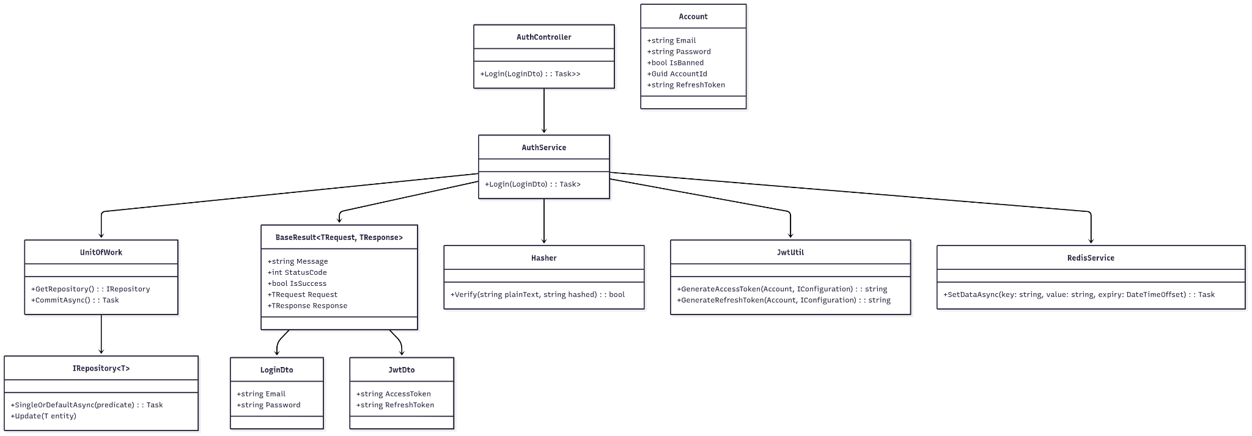

3.1.2 Sequence diagram
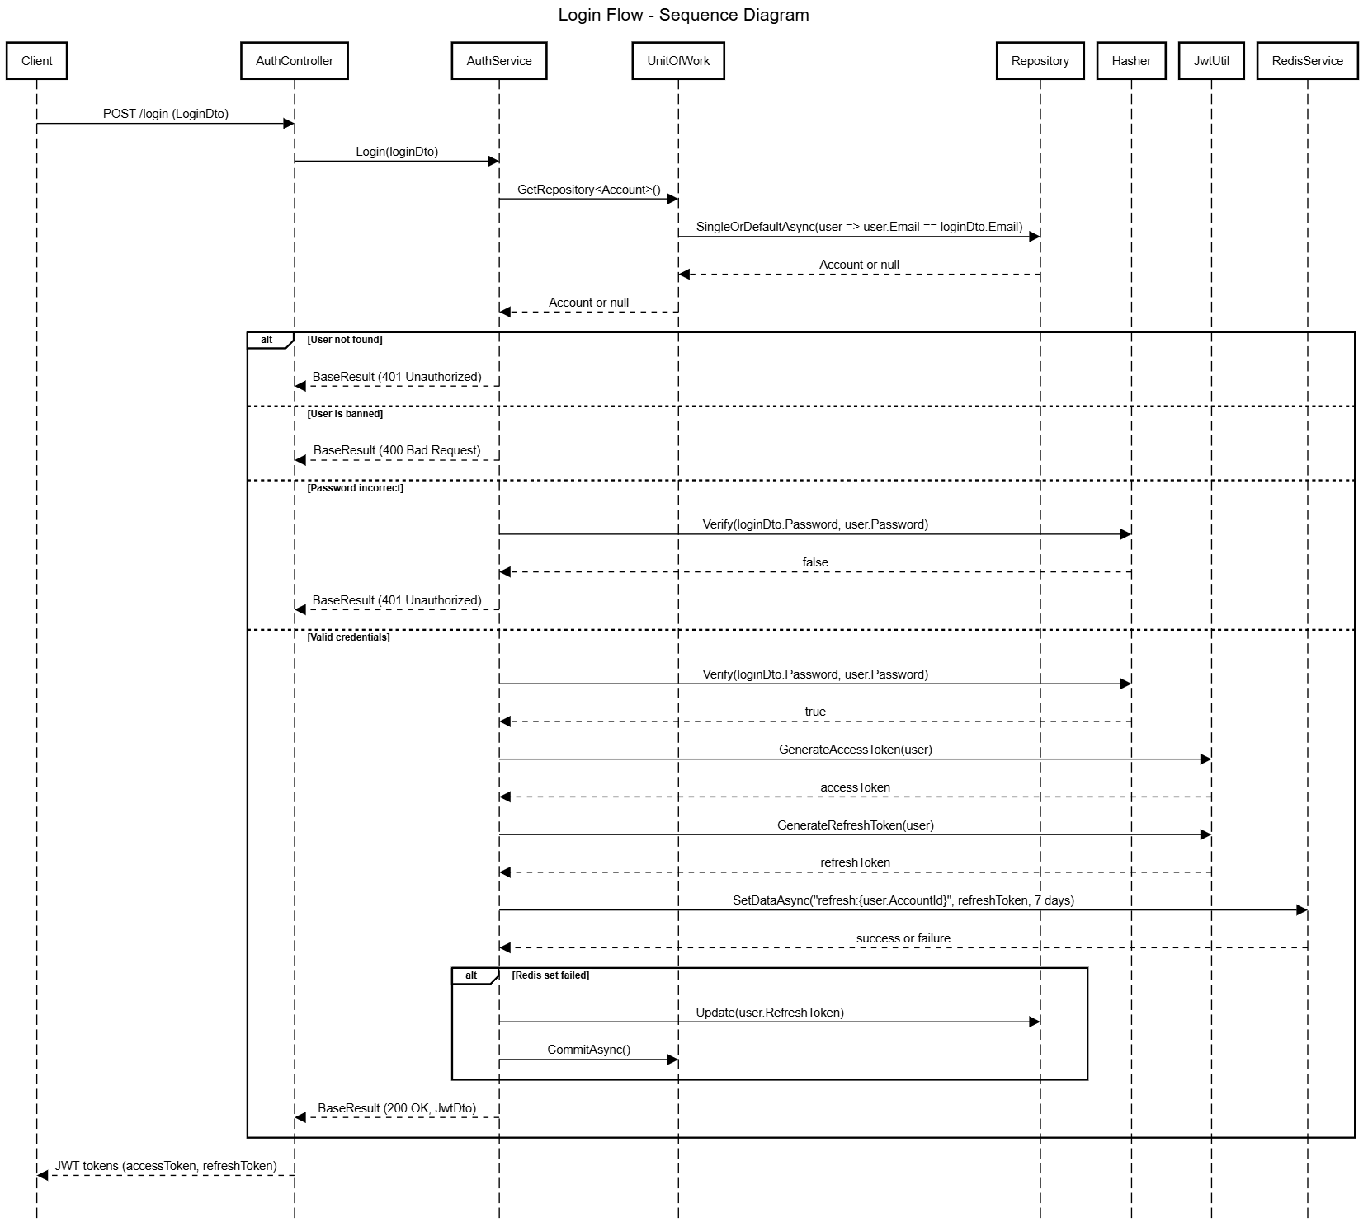

3.1.3 Class Specification

3.1.3.1 Auth Controller Description Table
Figure 3.1.3.1 Auth Controller Description Table
No | Method | Description
01 | Login(LoginDto ) | Handles POST requests to authenticate a user using their email and password. If the credentials are valid, return a JWT access token and refresh token. Otherwise, returns an error response with appropriate status code and message.

3.1.3.2 Auth Service Description Table
Figure 3.1.3.2 Auth Service Description Table
No | Method | Description
01 | Login(LoginDto) | Verifies user credentials. Retrieves the account by email, checks for bans and password correctness, and generates JWT tokens. Stores refresh token either in Redis or falls back to the database. Returns login result as BaseResult<LoginDto, JwtDto>.

3.1.3.2 Auth DTOs Description Table
Figure 3.1.3.2 Auth Service Description Table
No | Method | Description
01 | LoginDto | Data transfer object for login request. Contains Email and Password fields, both marked as required.
02 | JwtDto | Data transfer object returned after successful login. Includes the AccessToken and RefreshToken strings used for authentication and session management.
03 | BaseResult<TRequest, TResponse> | A generic wrapper class for API responses. Includes metadata like message, status code, success flag, original request data, and response data.

3.2 Login Admin

3.2.1 Class Diagram
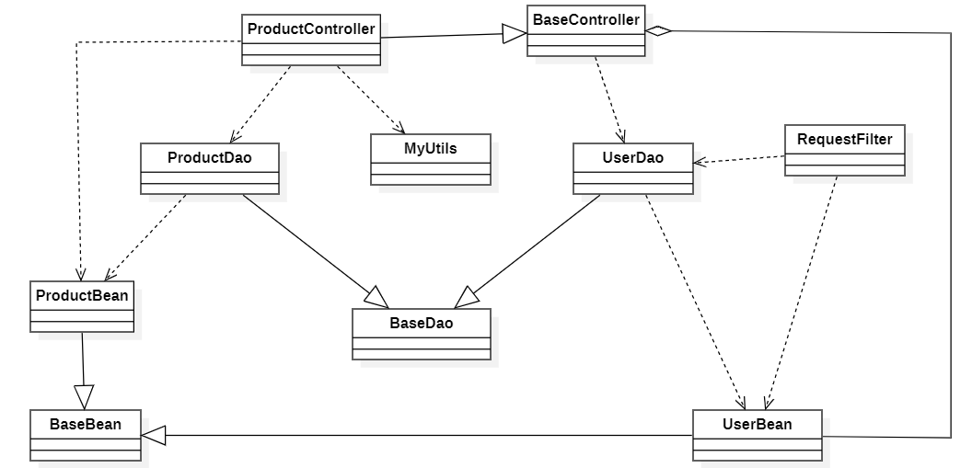

3.2.2 Sequence diagram
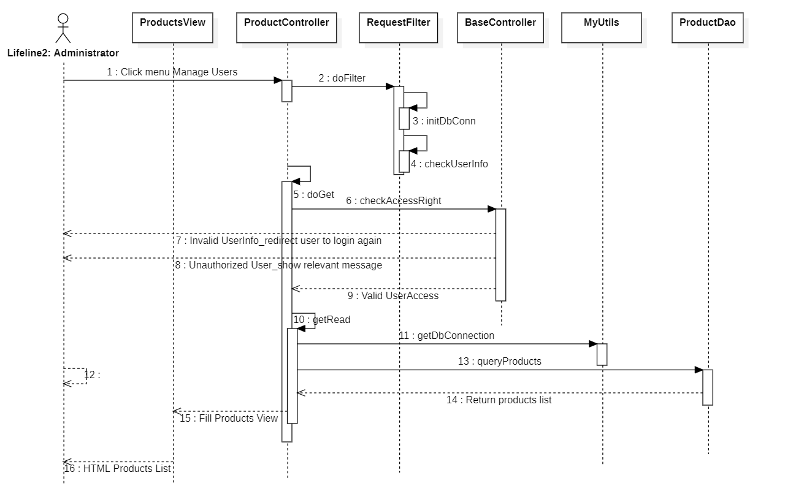

3.2.3 Class Specification

3.2.3.1 Auth Controller Description Table
Figure 3.2.3.1 Auth Controller Description Table
No | Method | Description
01 | LoginAdmin(LoginRequest loginRequest) | Handles the Customer login process by  validating the provided phone number and  password, then returns authentication  tokens.

3.2.3.2 Auth Service Description Table
Figure 3.2.3.2 Auth Service Description Table
No | Method | Description
01 | LoginRequest | Handles the Customer login process by  validating the provided phone number and  password, then  returns authentication tokens.

3.2.3.2 Auth DTOs Description Table
Figure 3.2.3.2 Auth DTOs Description Table
No | Method | Description
01 | LoginRequest | Contains the username and password  for authentication
02 | LoginResponse | Contains the authentication tokens

3.3 Refresh Token

3.3.1 Class Diagram
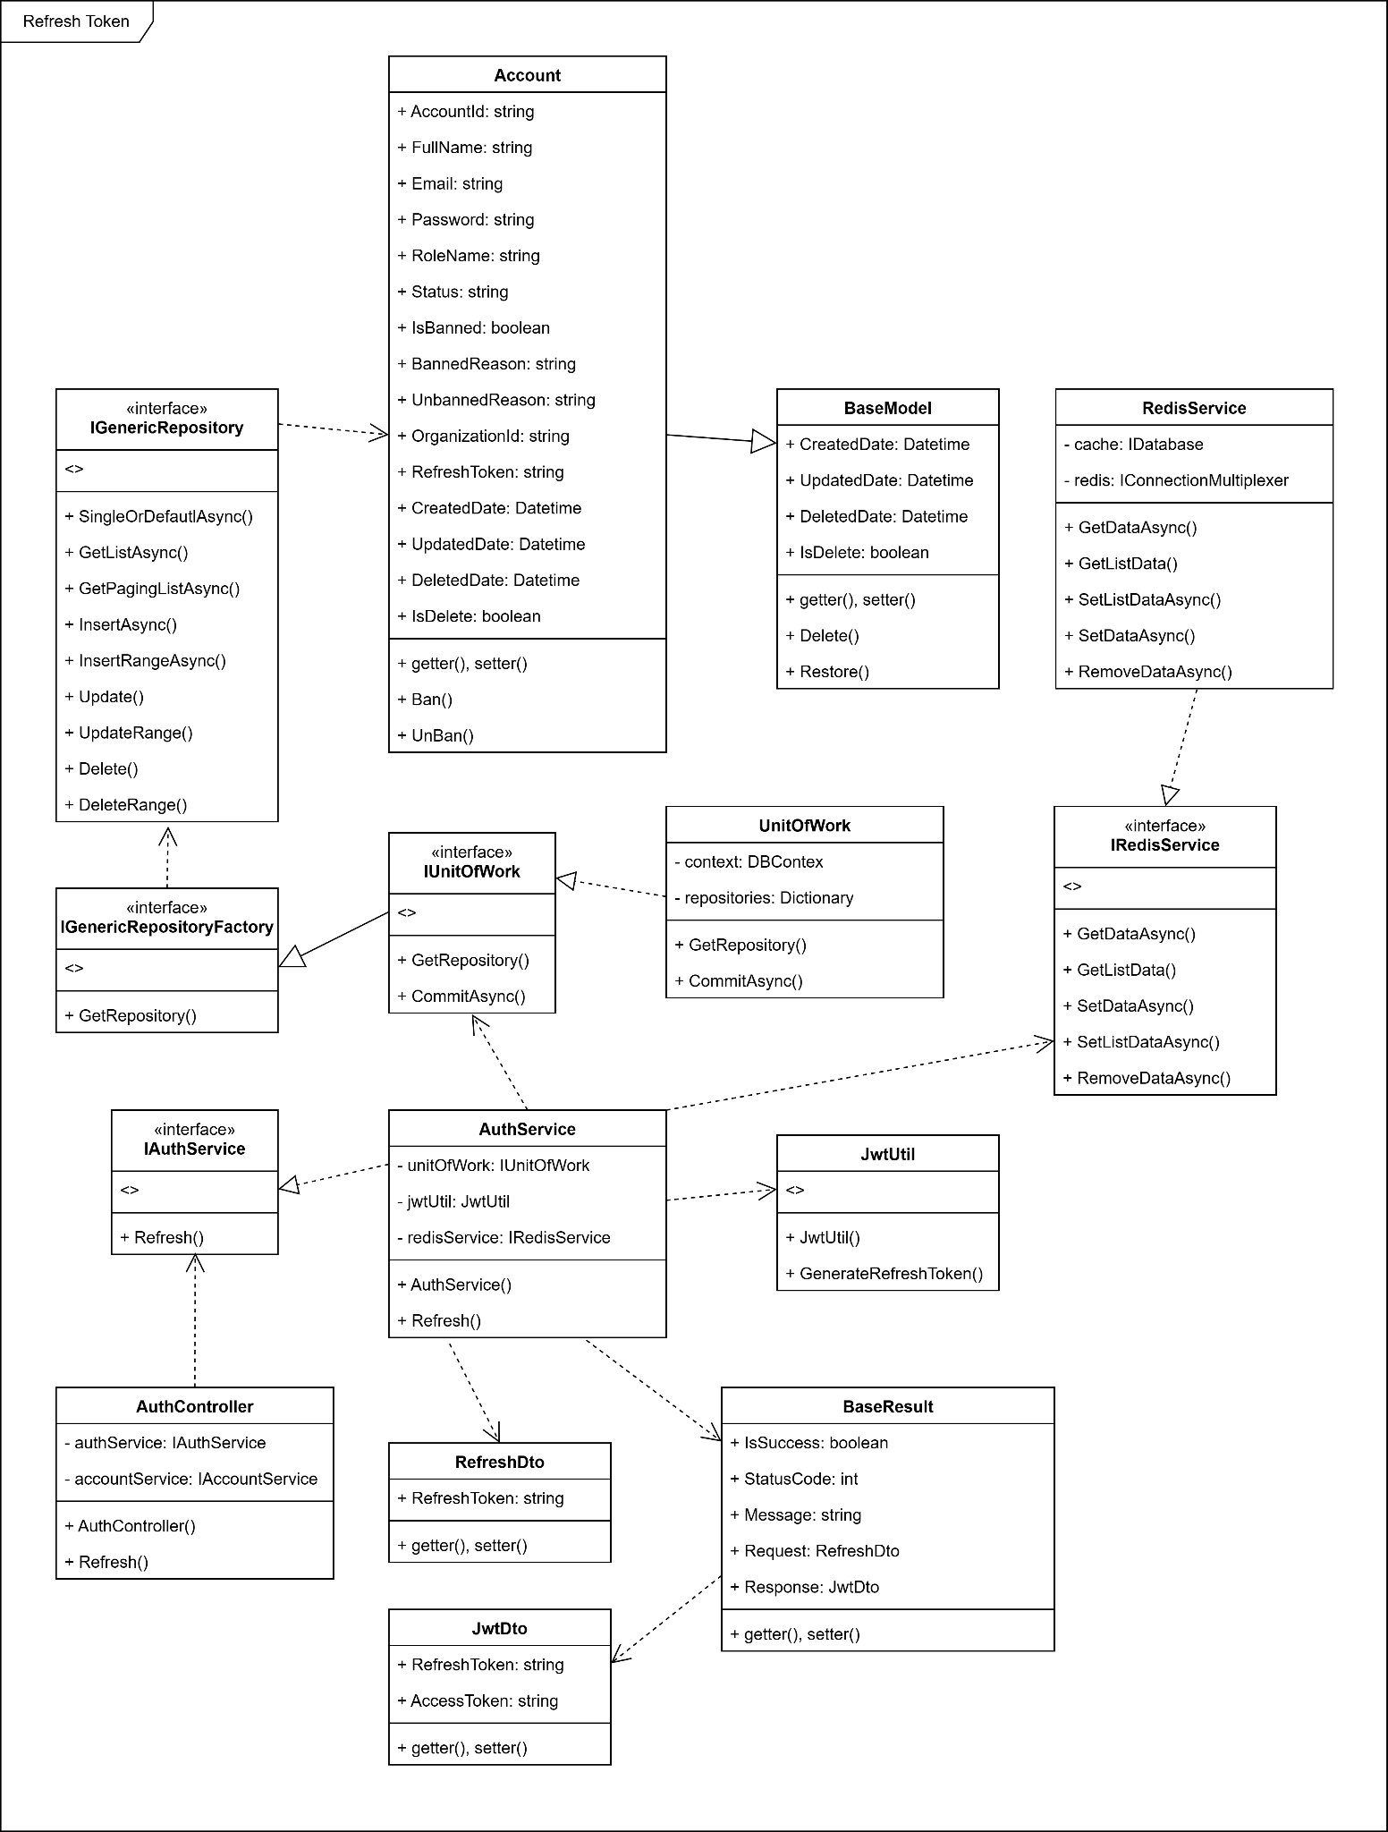

3.3.2 Sequence diagram
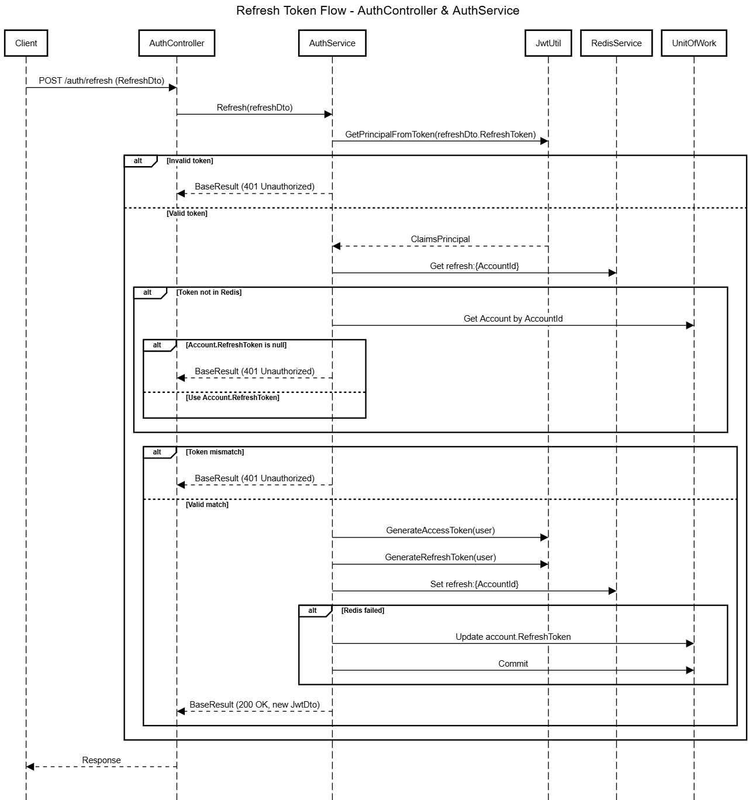

3.3.3 Class Specification

3.3.3.1 AuthController Description Table
Figure 3.3.3.1 Auth Controller Description Table
No | Method | Description
01 | Refresh(RefreshDto dto) | Handle HTTP POST /auth/refresh; forwards request to AuthService.Refresh()
02

3.3.3.2 AuthService Description Table
Figure 3.3.3.2 Auth Service Description Table
No | Method | Description
01 | Refresh(RefreshDto dto) | Validates refresh token, compares with Redis/DB, and generates new access/refresh tokens
02 | JwtUtil.GetPrincipalFromToken() | Used to extract user claims from refresh token
03 | RedisService.GetDataAsync() | Used to retrieve the currently stored refresh token from Redis
04 | RedisService.SetDataAsync() | Used to update the refresh token in Redis for the account
05 | UnitOfWork.GetRepository<Account>() | Fetch account to compare refresh token or update fallback token when Redis is unavailable

3.3.3.2 JwtUtil Description Table
Figure 3.3.3.2 JwtUtil Description Table
No | Method | Description
01 | GetPrincipalFromToken(string token, IConfiguration config) | Decode and validate refresh token, extract user claims
02 | GenerateAccessToken(Account, IConfiguration) | Create a new short-lived JWT access token
03 | GenerateRefreshToken(Account, IConfiguration) | Generate a new long-lived refresh token

3.3.3.3 RedisService Description Table
Figure 3.3.3.2 Redis ServiceDescription Table
No | Method | Description
01 | GetDataAsync<string>(key) | Retrieve stored refresh token from Redis using key pattern refresh:{id}
02 | SetDataAsync(key, value, expiry) | Save new refresh token in Redis with 7-day TTL

3.3.3.4 UnitOfWork Description Table
Figure 3.3.3.2 UnitOfWork DTOs Description Table
No | Method | Description
01 | GetRepository<Account>() | Access Account repository to read user or update refresh token fallback
02 | CommitAsync() | Persist account token fallback update if Redis fails

3.4 Create Organization

3.4.1 Class Diagram
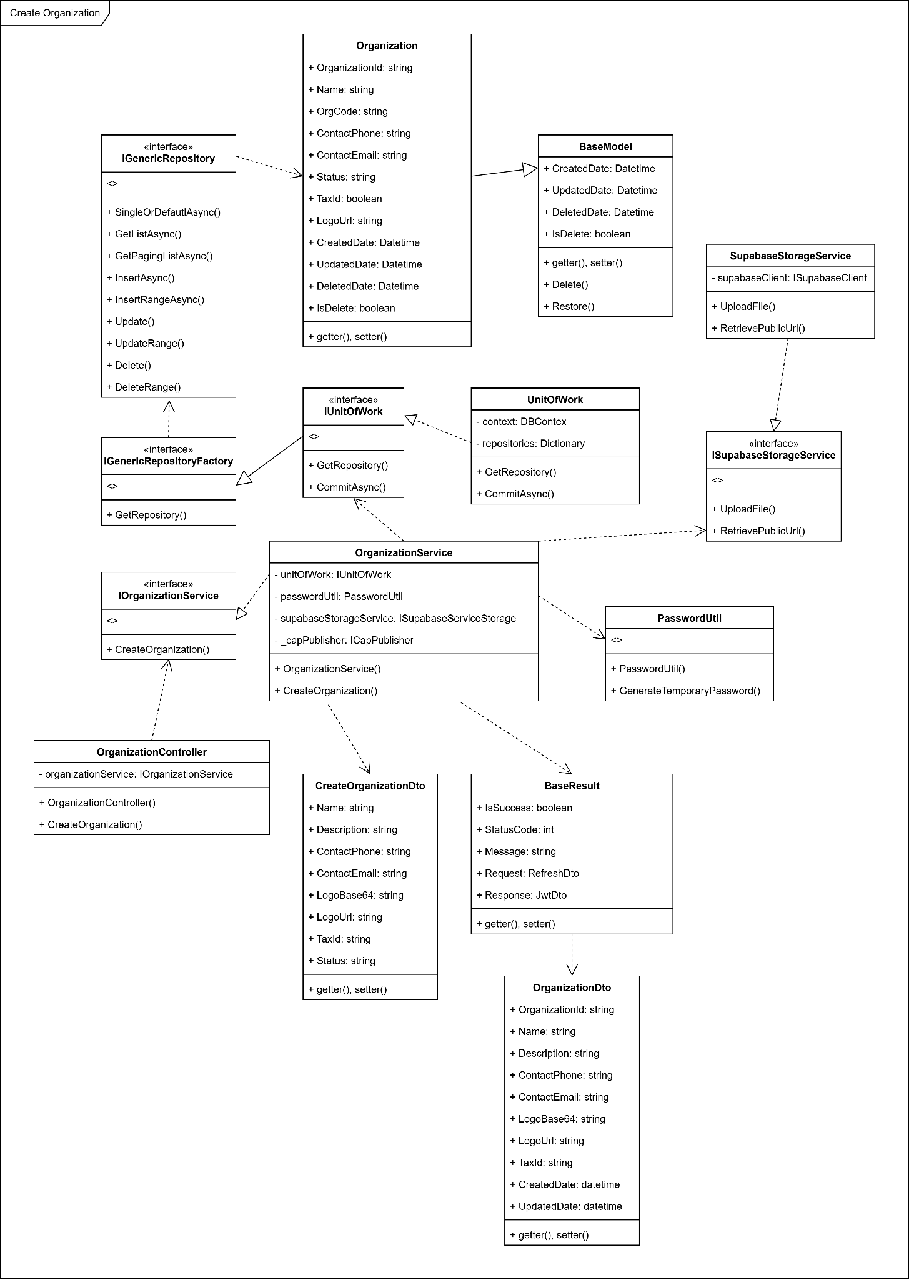

3.4.2 Sequence diagram
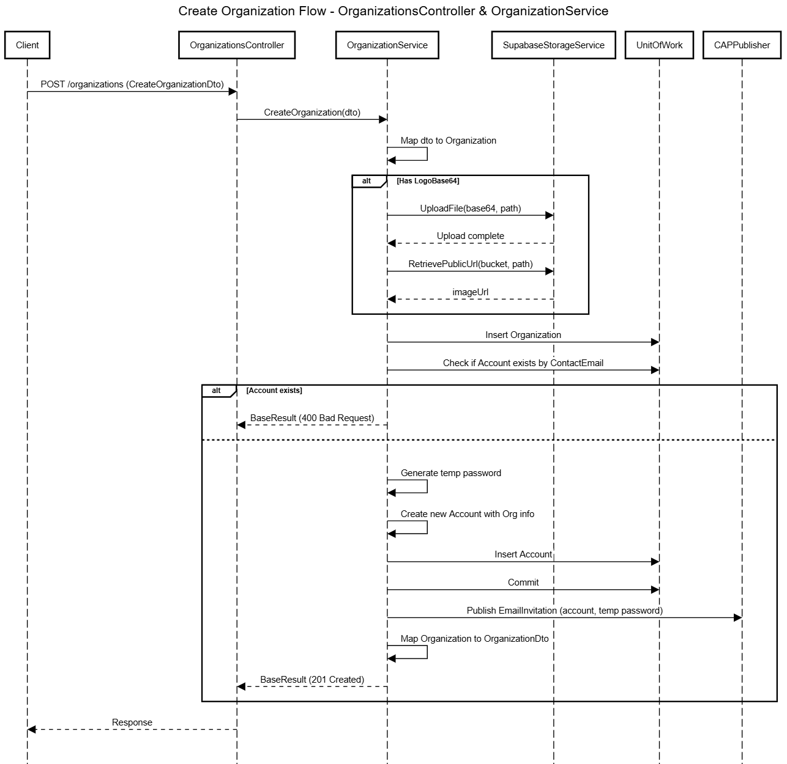

3.4.3 Class Specification

3.4.3.1 Organization Controller Description Table
Figure 3.4.3.1 Organization Controller Description Table
No | Method | Description
01 | Post(CreateOrganizationDto dto) | Handles HTTP POST /organizations; calls OrganizationService.CreateOrganization() to create a new organization

3.4.3.2 Organization Service Description Table
Figure 3.4.3.2 Organization Service Description Table
No | Method | Description
01 | CreateOrganization(CreateOrganizationDto dto) | Creates a new organization, uploads logo to Supabase, generates organization account, sends invitation email

3.4.3.2 Supabase Storage Service Description Table
Figure 3.4.3.2 Supabase Storage Service Description Table
No | Method | Description
01 | UploadFile(byte[], path, bucket, overwrite) | Uploads the organization's logo to Supabase Storage
02 | RetrievePublicUrl(bucket, path) | Retrieves the public URL of the uploaded logo

3.4.3.3 UnitOfWork Description Table
Figure 3.4.3.2 UnitOfWork Description Table
No | Method | Description
01 | GetRepository<T>() | Retrieves the repository instance for entities like Organization, Account
02 | CommitAsync() | Commits all changes to the database

3.4.3.4 CapPublisher Description Table
Figure 3.4.3.2 CapPublisher Description Table
No | Method | Description
01 | PublishAsync(topic, EmailInvitationCapMessage) | Publishes an email invitation event containing login credentials to the message bus

3.5 Create Kiosk

3.5.1 Class Diagram
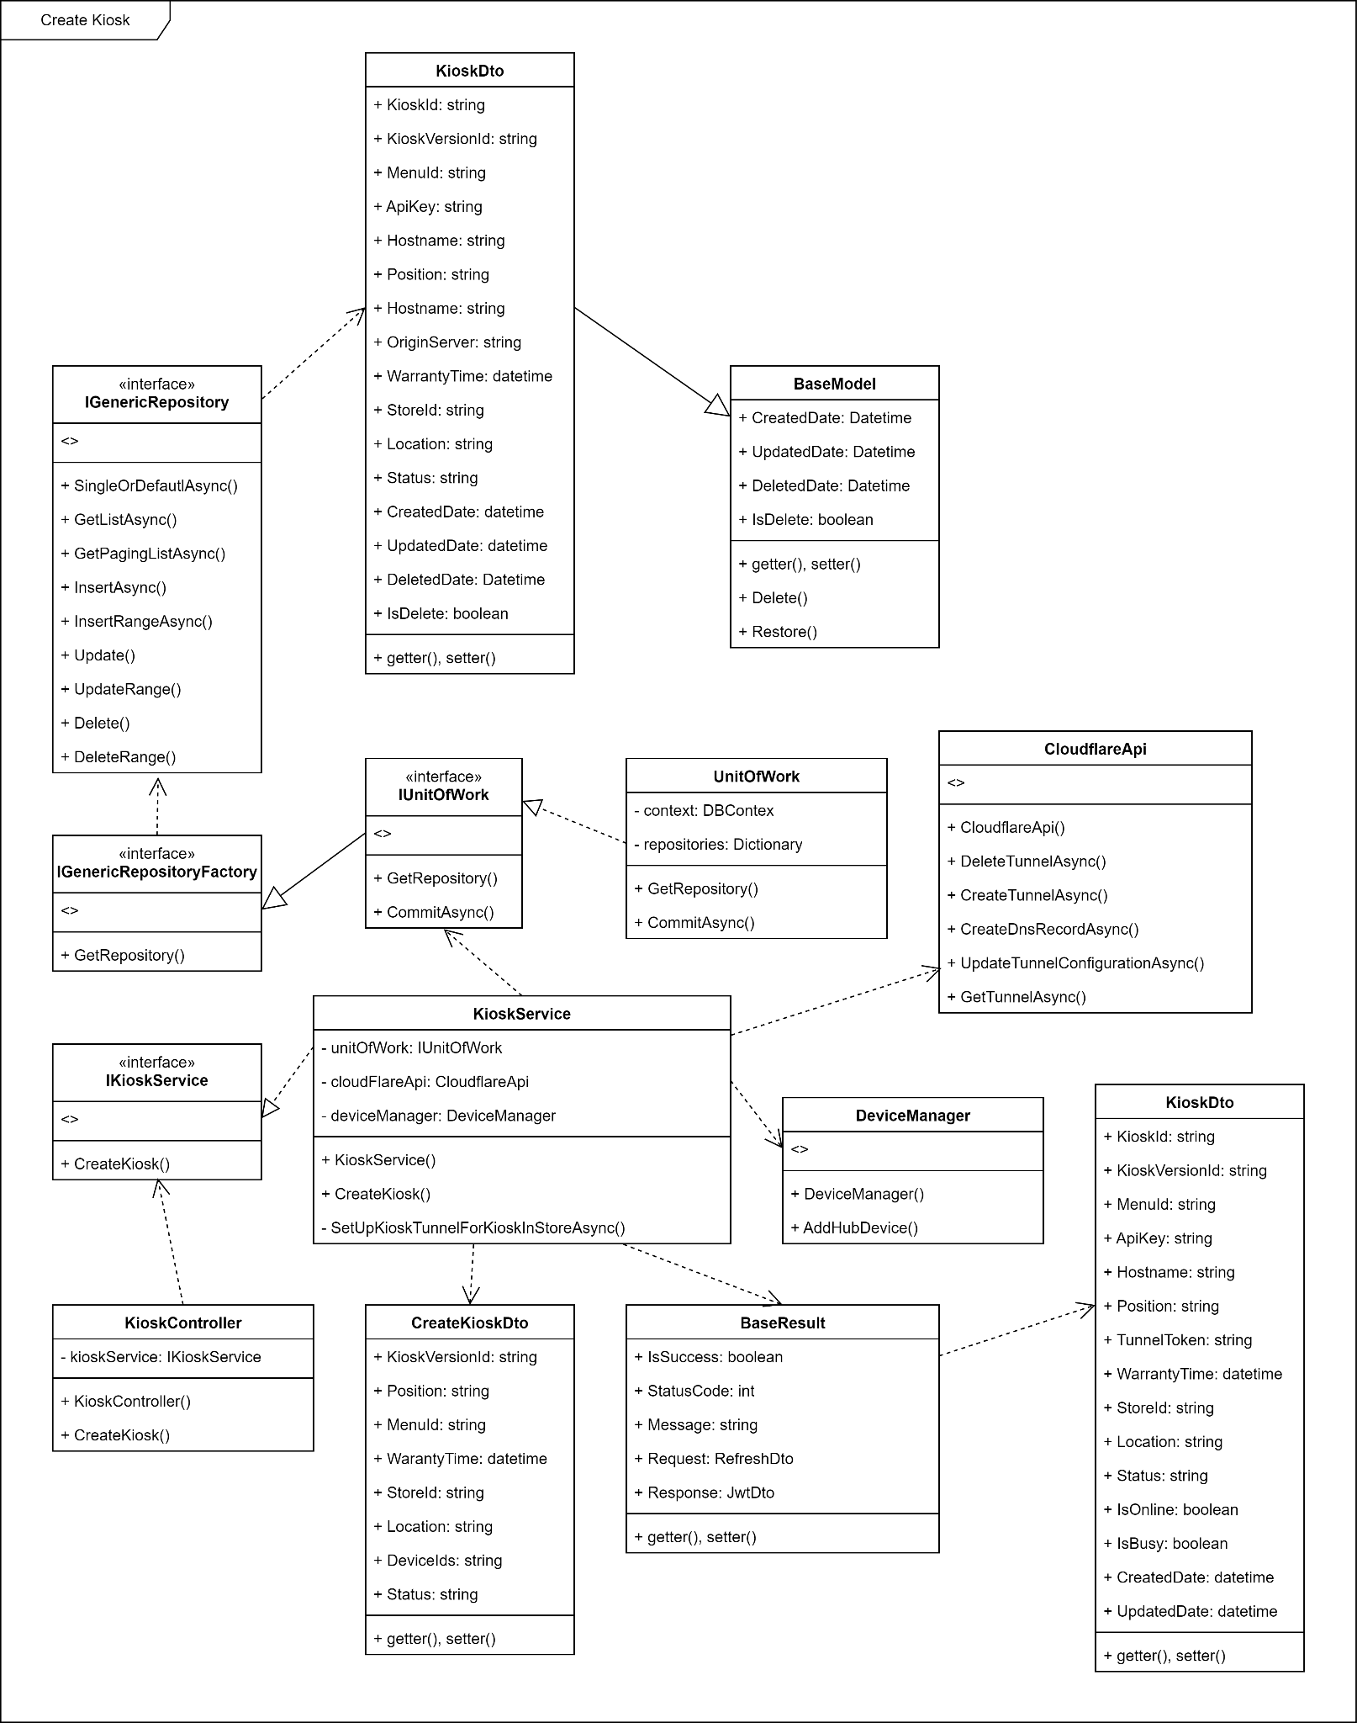

3.5.2 Sequence diagram
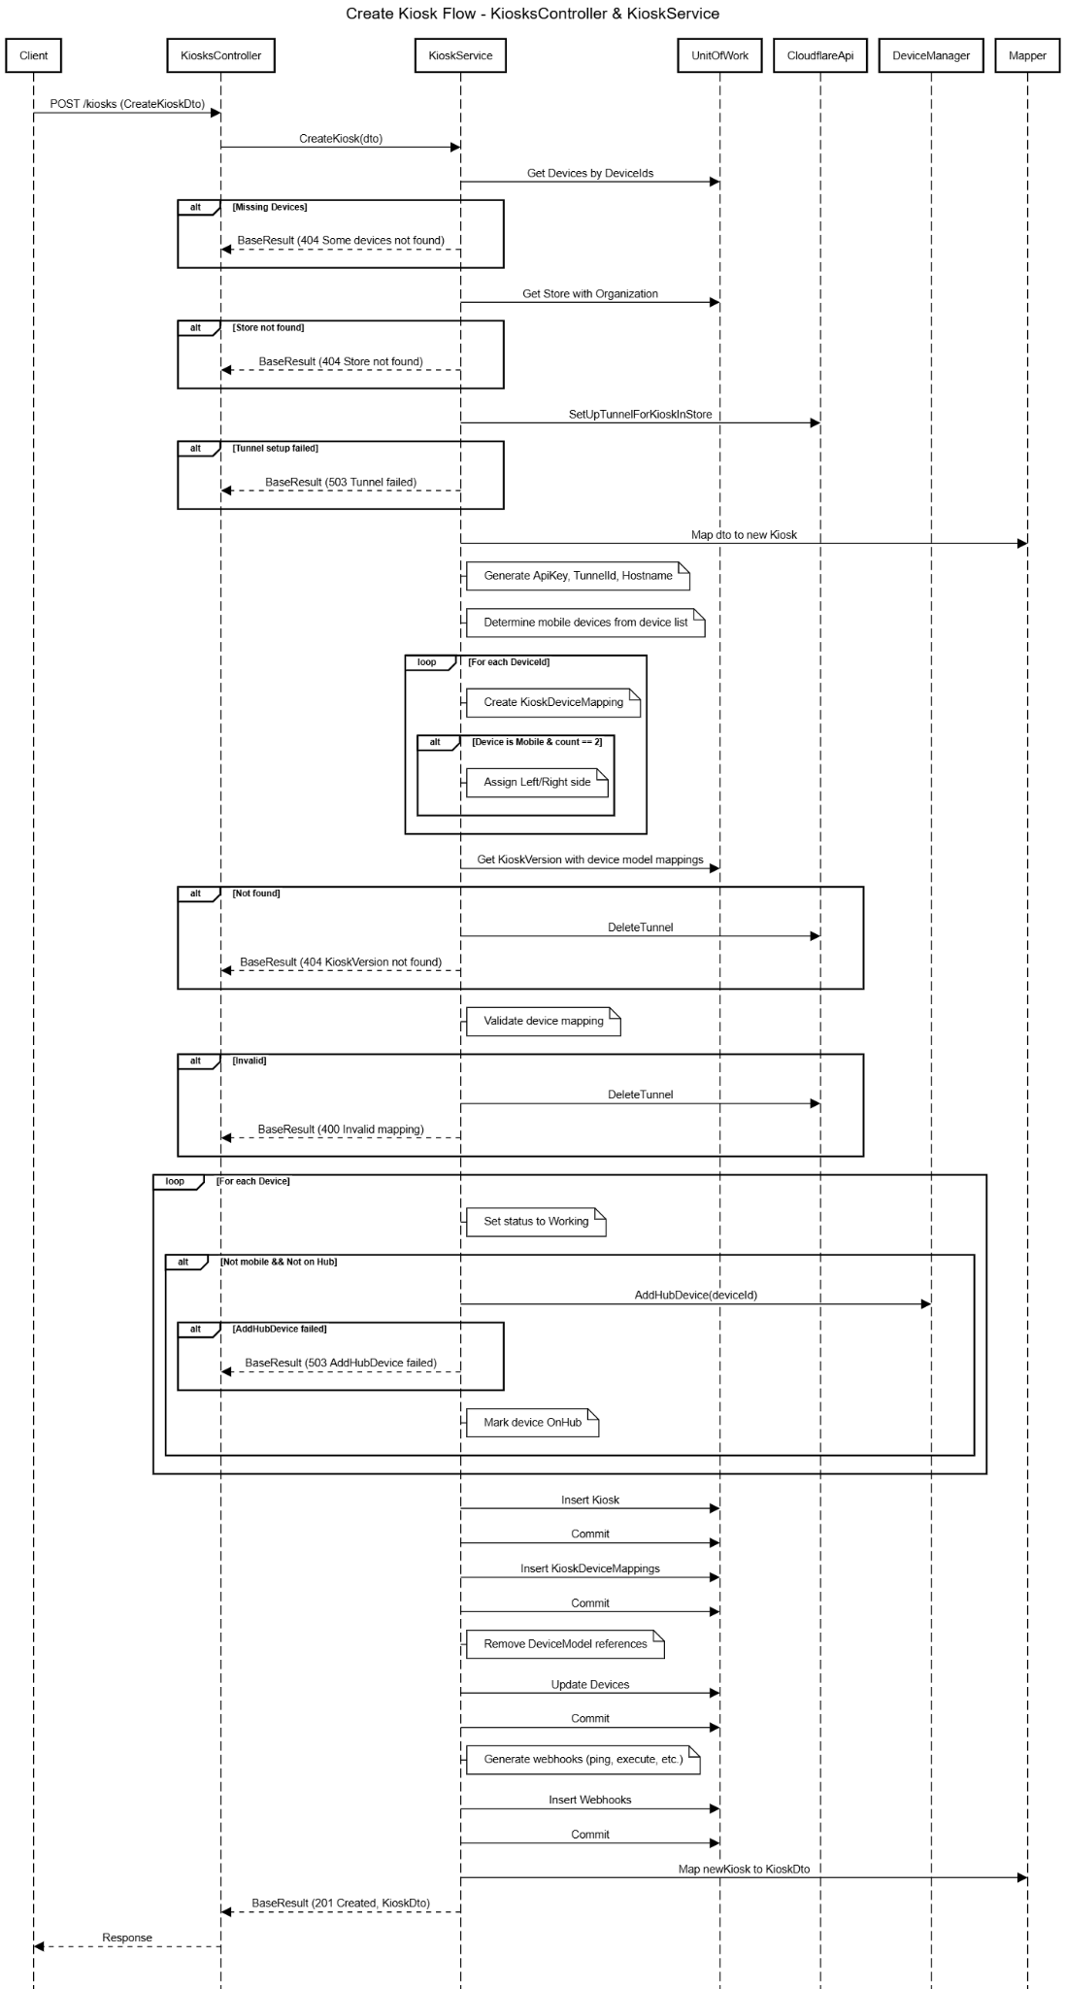

3.5.3 Class Specification

3.5.3.1 Kiosk Controller Description Table
Figure 3.5.3.1 Kiosk Controller Description Table
No | Method | Description
01 | Post(CreateKioskDto dto) | Handles HTTP POST /kiosks, calls KioskService.CreateKiosk() to create new kiosk

3.5.3.2 Kiosk Service Description Table
Figure 3.5.3.2 Kiosk Service Description Table
No | Method | Description
01 | CreateKiosk(CreateKioskDto dto) | Creates new kiosk, maps devices, creates Cloudflare tunnel, validates model, registers webhooks
02 | SetUpTunnelForKioskInStoreAsync(string orgCode) | Creates Cloudflare tunnel and DNS record based on organization code
03 | ValidKioskDevices(...) | Validates number and model of selected devices match version specification

3.5.3.2 UnitOfWork Description Table
Figure 3.5.3.2 UnitOfWork Description Table
No | Method | Description
01 | GetRepository<T>() | Gets repository to access Kiosk, Device, Store, KioskVersion, etc.
02 | CommitAsync() | Persists all changes to database after inserting kiosk and device mappings

3.5.3.3 Cloudflare Client Description Table
Figure 3.5.3.2 Cloudflare Client Description Table
No | Method | Description
01 | CreateTunnelAsync(string tunnelName) | Creates a new Cloudflare tunnel for a kiosk
02 | CreateDnsRecordAsync(string name, string tunnelId) | Creates a DNS record linked to the tunnel
03 | UpdateTunnelConfigurationAsync(...) | Updates tunnel to include hostname and forwarding service
04 | DeleteTunnelAsync(string tunnelId) | Deletes a tunnel when kiosk creation fails

3.5.3.4 Device Manager Description Table
Figure 3.5.3.2 Device Manager Description Table
No | Method | Description
01 | AddHubDevice(string deviceId) | Registers device to Azure IoT Hub and returns metadata
02 | BuildDevicePrimaryConnectionStr() | Generates primary connection string for a given IoT Hub device
03 | GetHubDevice(string deviceId) | Retrieves device details from IoT Hub (used for non-mobile device setup)

3.6 Create Device Model

3.6.1 Class Diagram
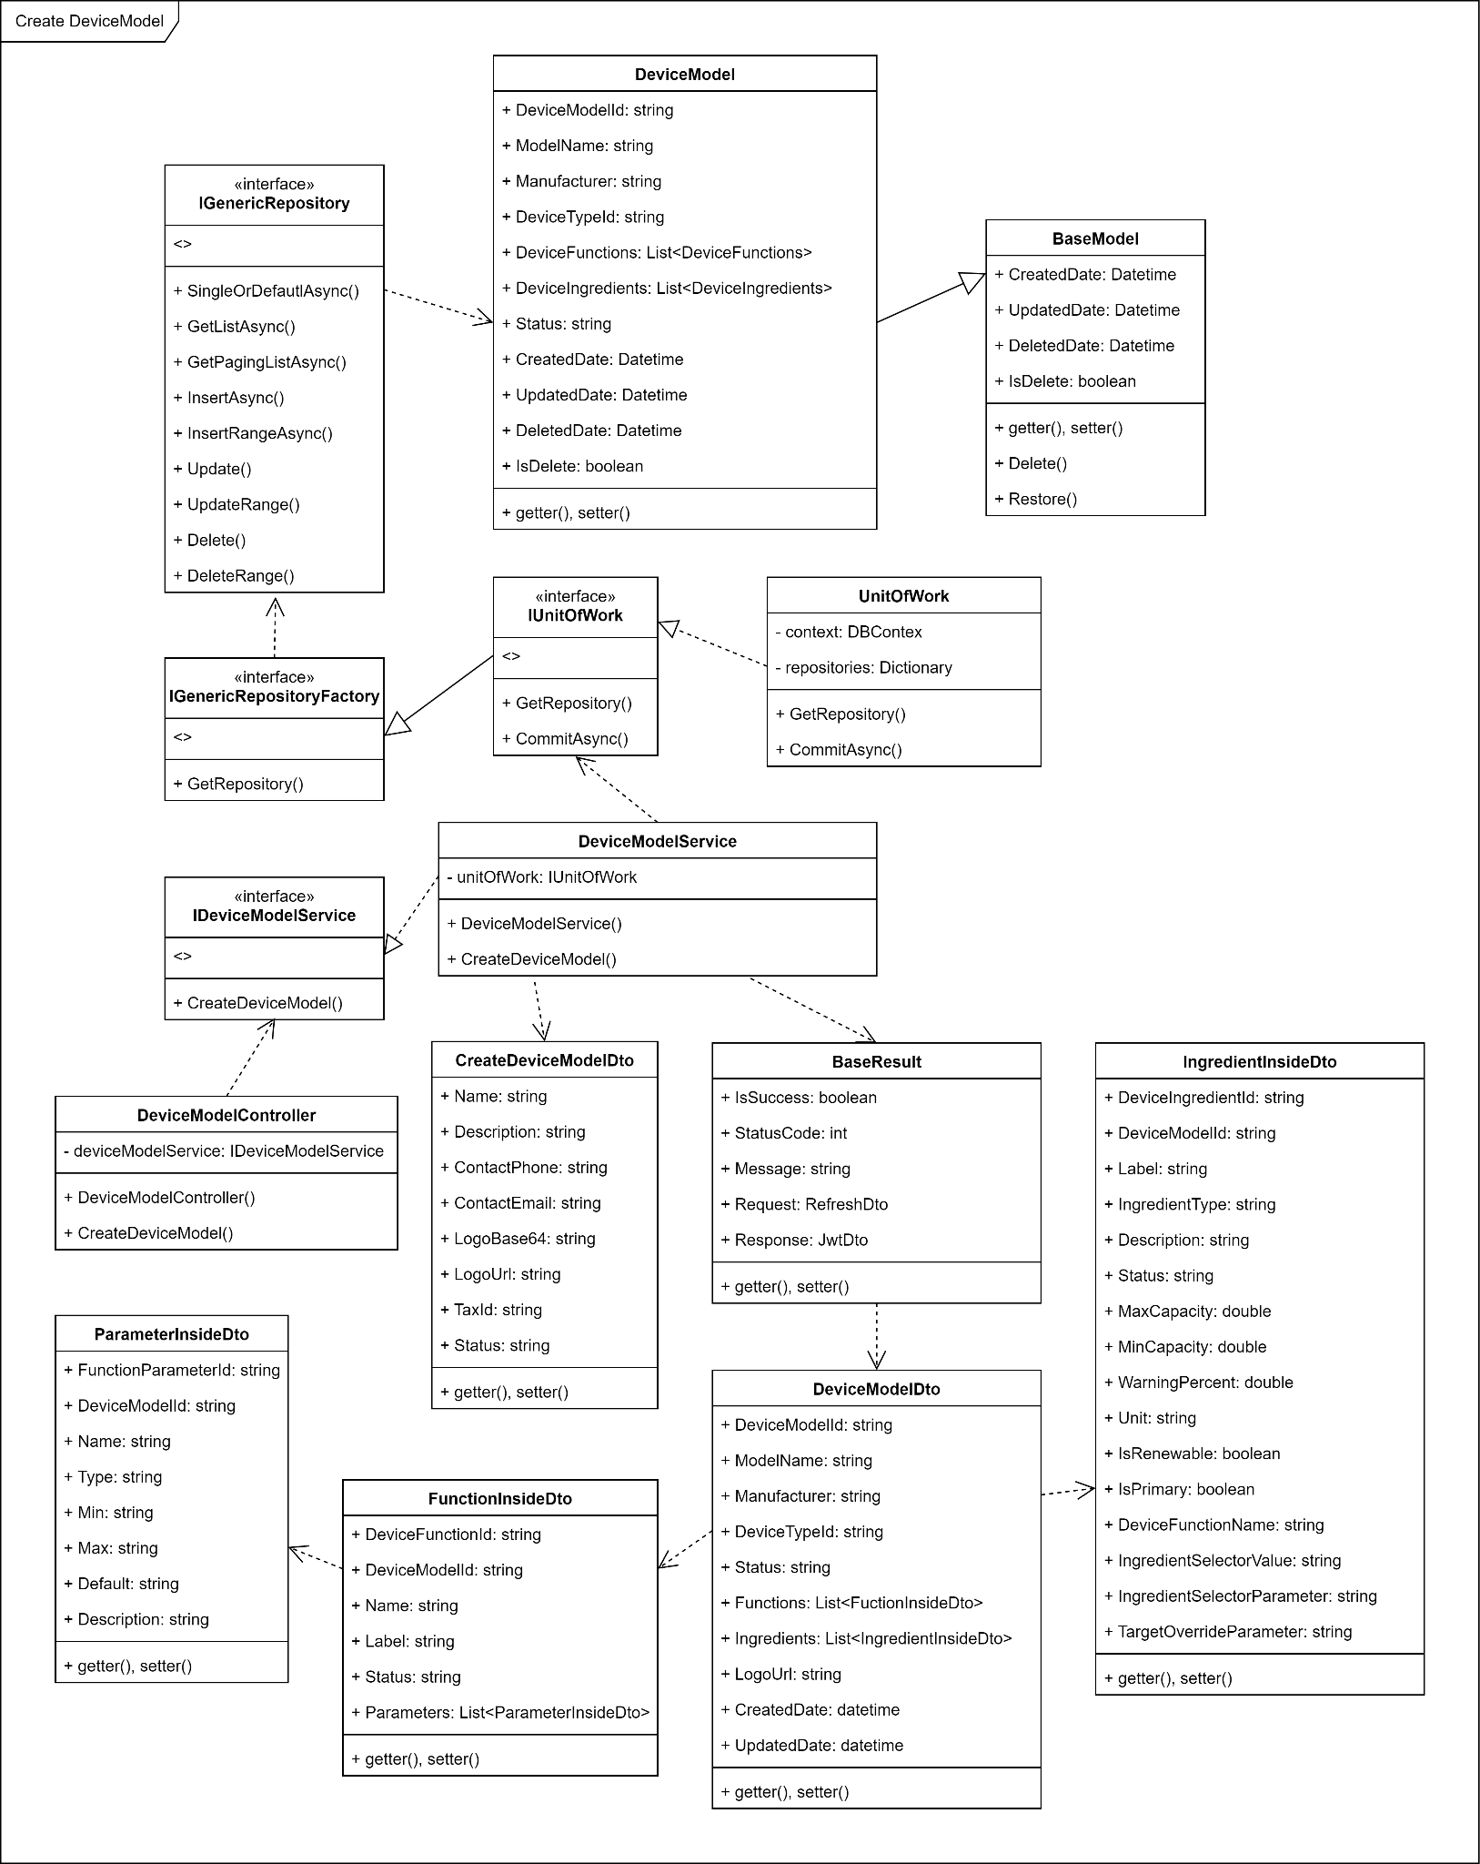

3.6.2 Sequence diagram
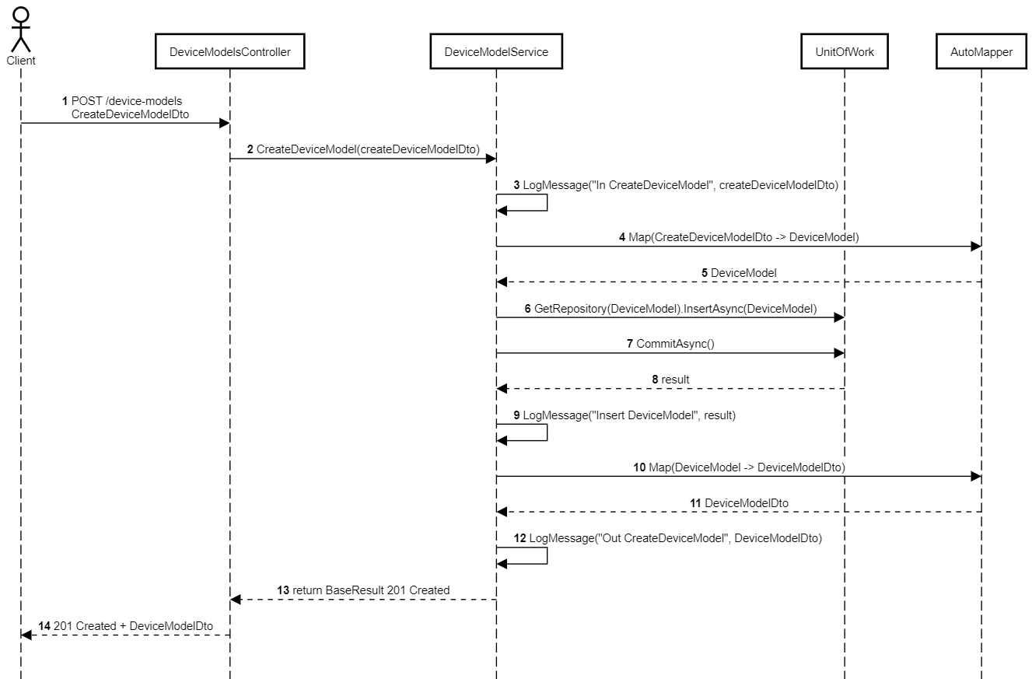

3.6.3 Class Specification

3.6.3.1 Device Model Controller Description Table
Figure 3.6.3.1 Device Model Controller Description Table
No | Method | Description
01 | Post([FromBody] CreateDeviceModelDto createDeviceModelDto) | Accepts a POST request from the client to create a new device model. It delegates the creation logic to DeviceModelService.CreateDeviceModel(), then returns the corresponding HTTP response.

3.6.3.2 Device Service Description Table
Figure 3.6.3.2 Device Service Description Table
No | Method | Description
01 | CreateDeviceModel(CreateDeviceModelDto createDeviceModelDto) | Handles business logic for creating a new device model. Maps DTO to entity, inserts into the database, commits the transaction, and returns a result DTO.
02 | GetDeviceModels(DeviceModelQueryDto) | Retrieves paginated list of device models based on filter criteria.

3.6.3.2 UnitOfWork Description Table
Figure 3.6.3.2 UnitOfWork Description Table
No | Method | Description
01 | GetRepository<DeviceModel>() | Provides access to the generic repository for the DeviceModel entity to perform database operations.
02 | CommitAsync() | Persists all pending changes made through repositories into the database.

3.7 Create Device

3.7.1 Class Diagram
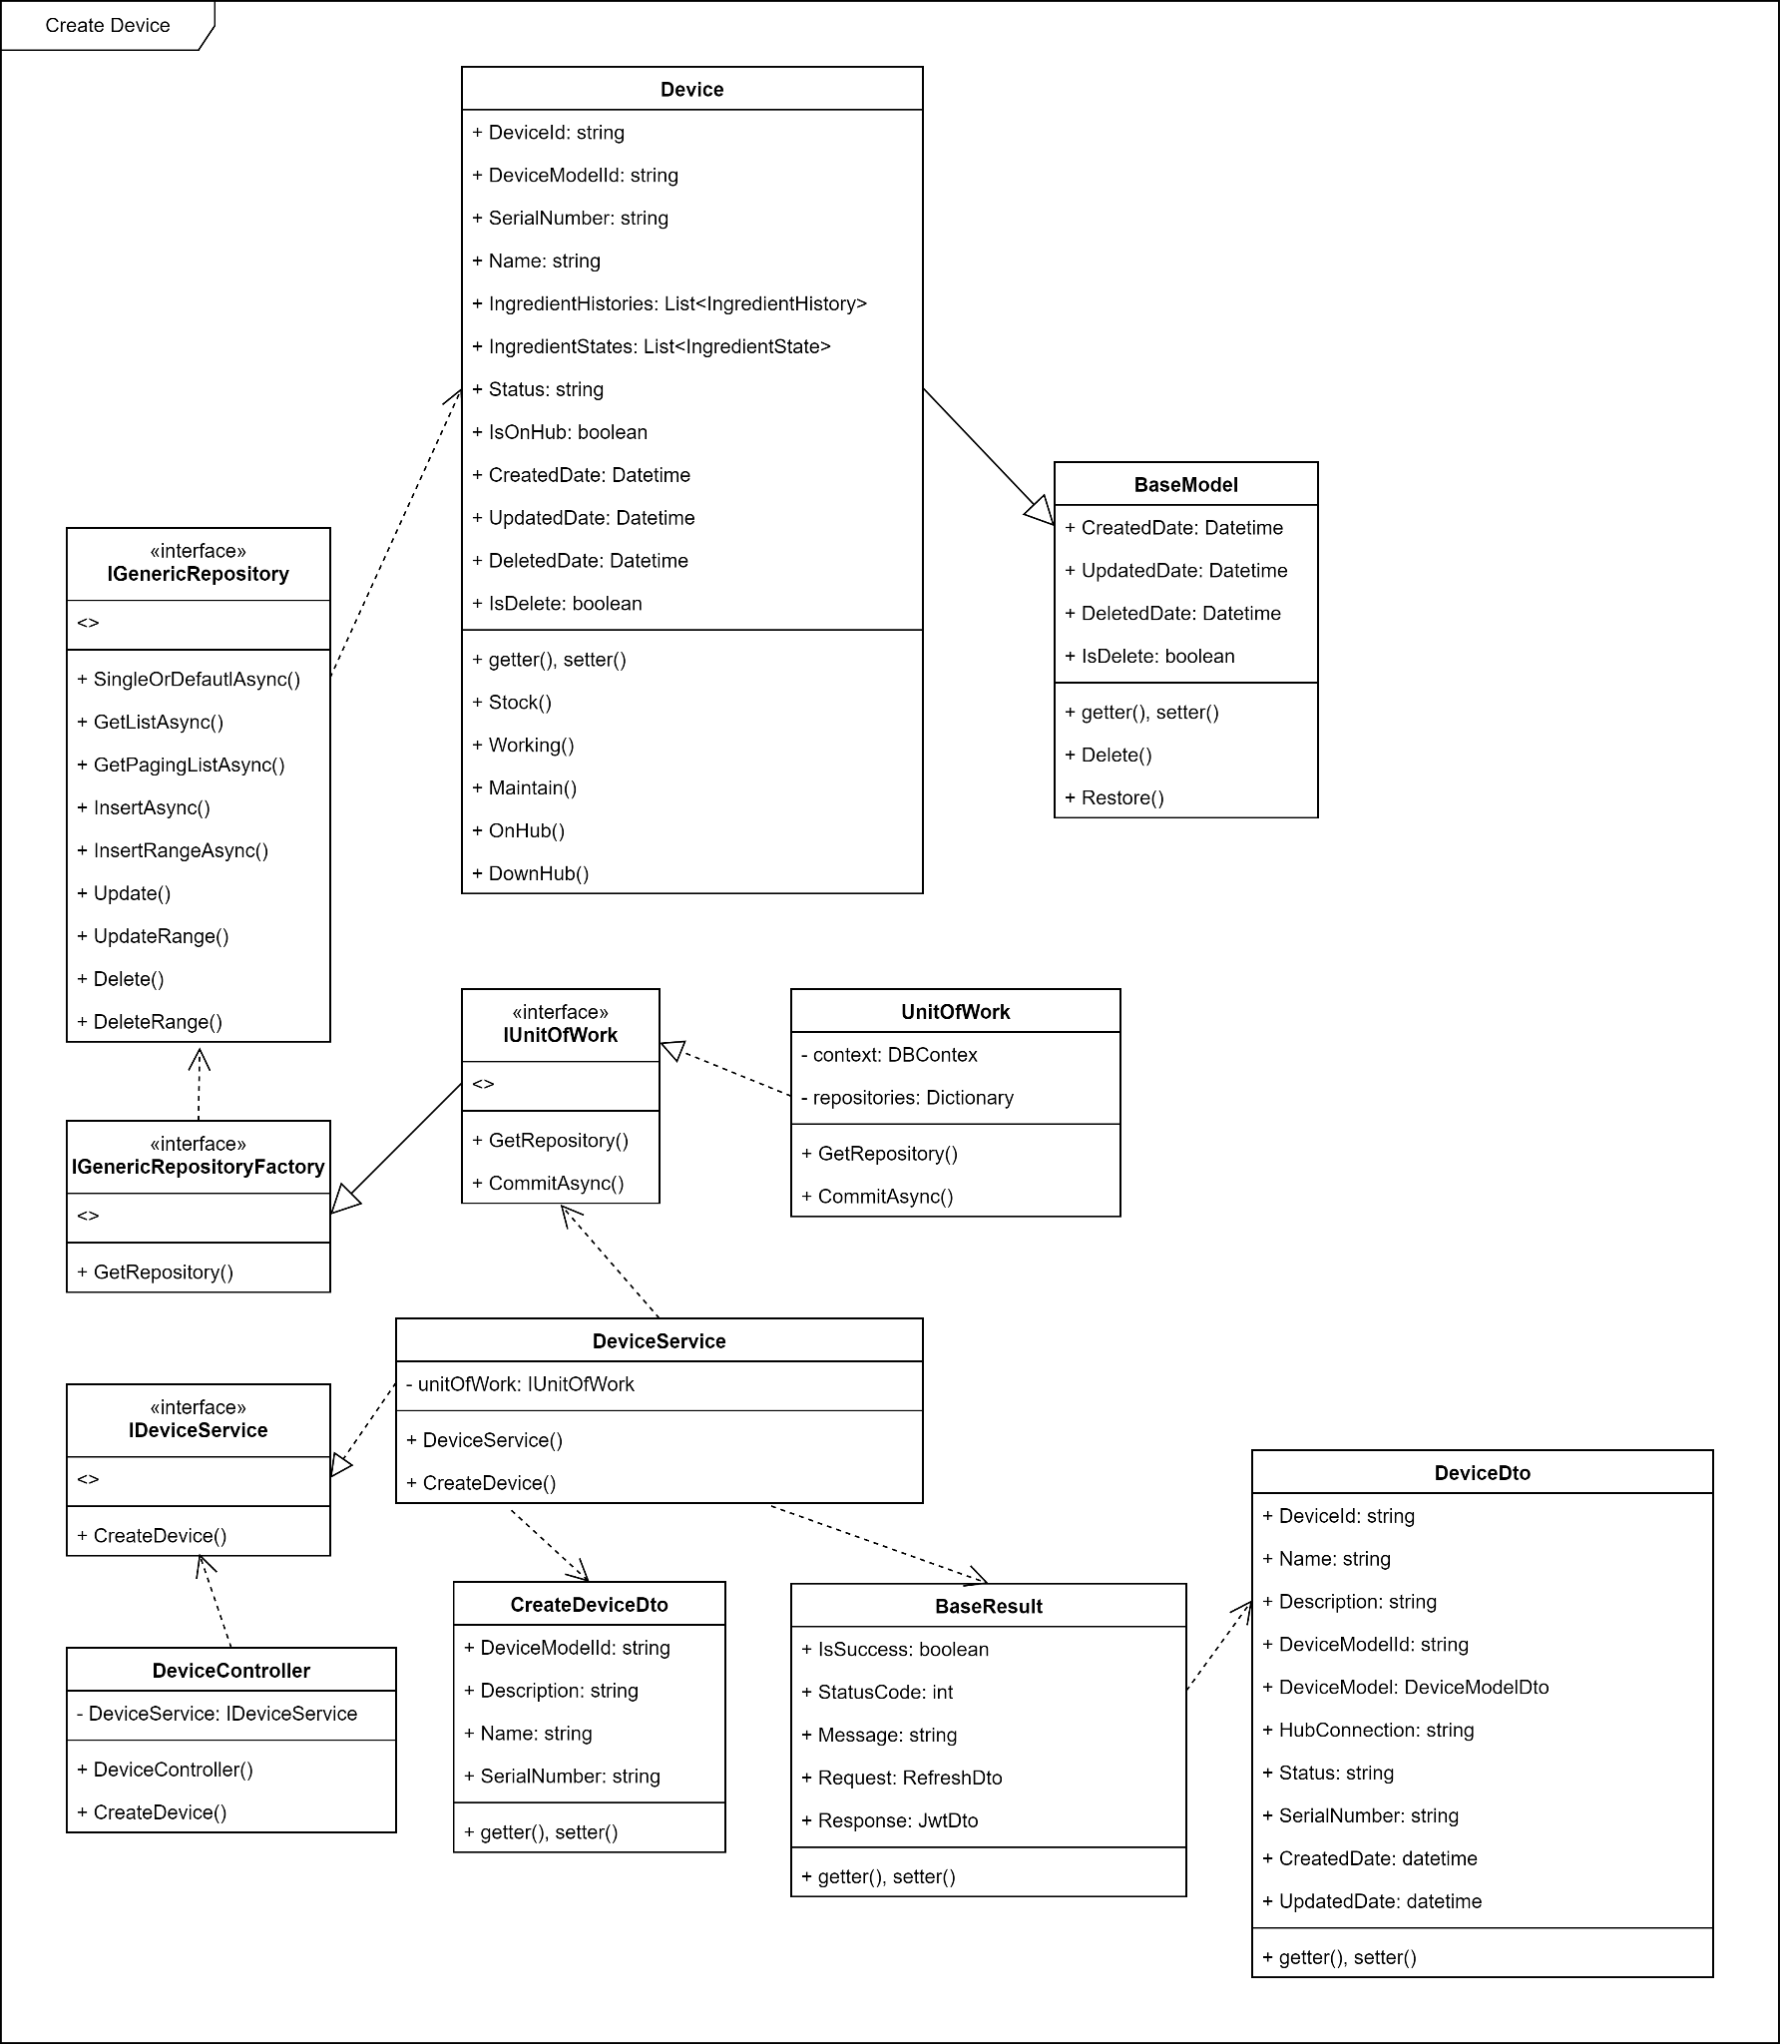

3.7.2 Sequence diagram
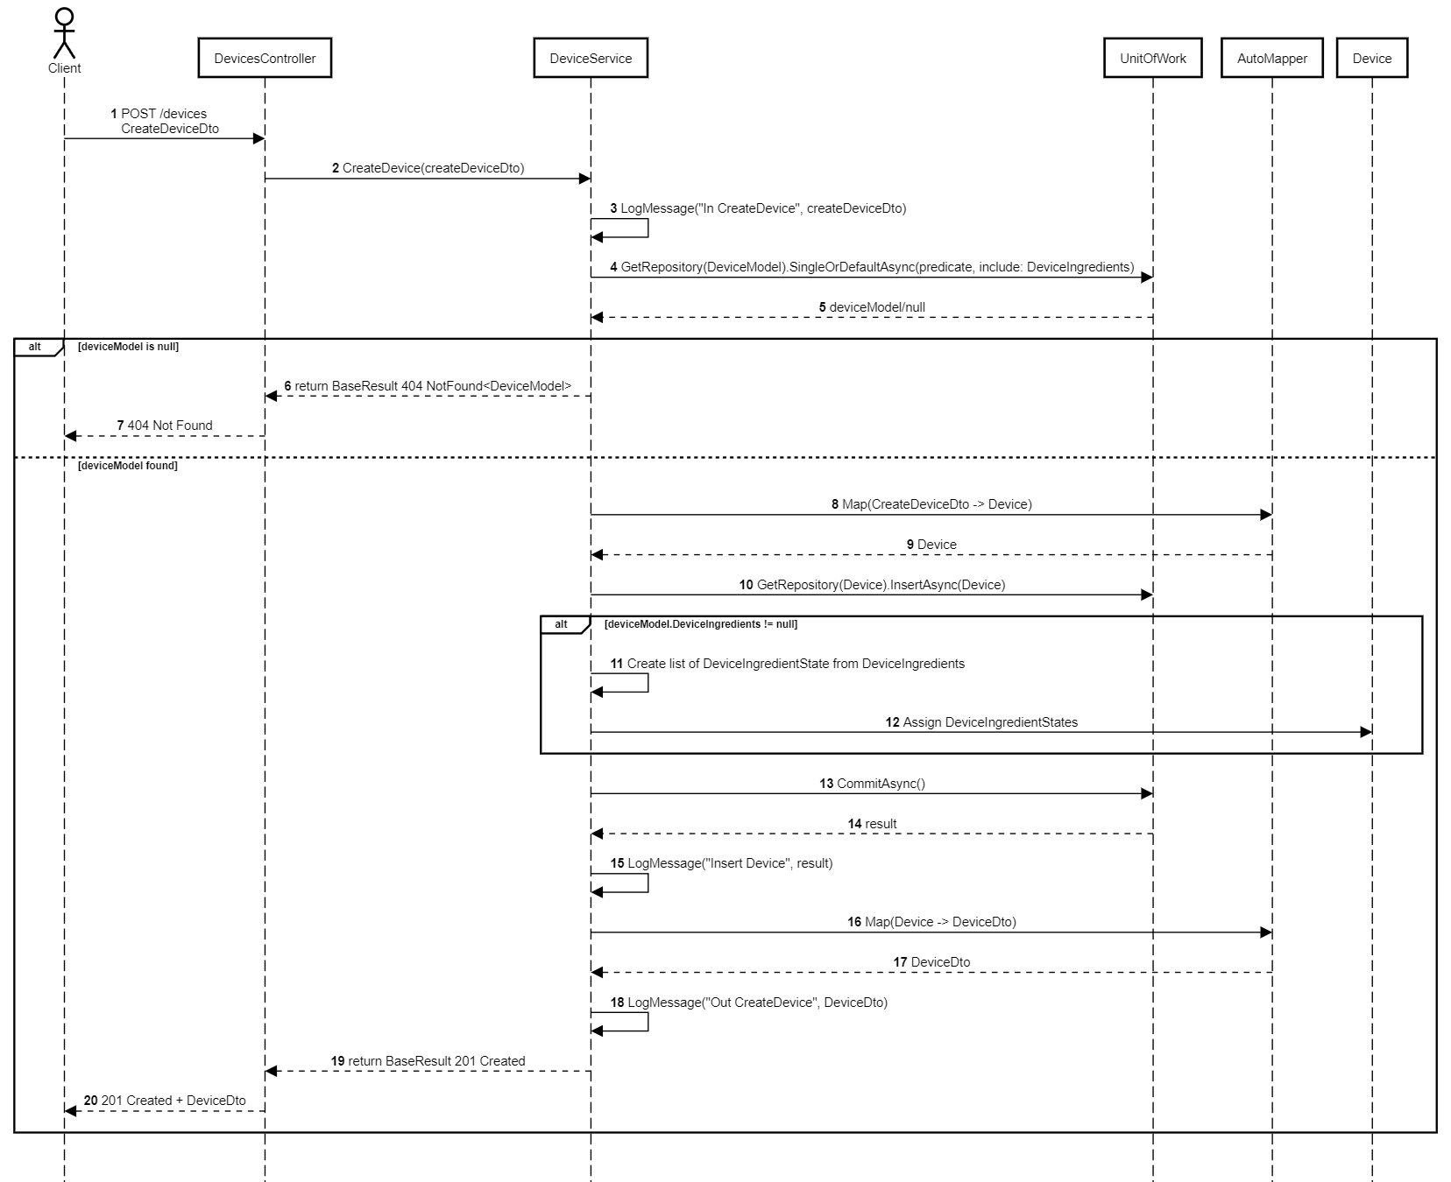

3.7.3 Class Specification

3.7.3.1 Device Controller Description Table
Figure 3.7.3.1 Device Controller Description Table
No | Method | Description
01 | Post(CreateDeviceDto createDeviceDto) | Handles the HTTP POST request to create a new device. Validates input, forwards it to DeviceService.CreateDevice, and returns the result to the client.
02 | Get(DeviceQueryDto deviceQueryDto) | Handles the HTTP GET request to retrieve a paginated list of devices with optional filters and sorting. Calls DeviceService.GetDevices and returns the paginated result.

3.7.3.2 Device Service Description Table
Figure 3.7.3.2 Device Service Description Table
No | Method | Description
01 | CreateDevice(CreateDeviceDto createDeviceDto) | Creates a new device entity. Fetches the related device model, maps the DTO to an entity, inserts it into the database, seeds DeviceIngredientState records if applicable, commits the transaction, and returns the created device DTO.
02 | GetDevices(DeviceQueryDto deviceQueryDto) | Retrieves a paginated list of devices from the database based on filter, status, and model criteria. Maps the result set to DeviceDto objects.

3.7.3.2 UnitOfWork Description Table
Figure 3.7.3.2 UnitOfWork Description Table
No | Method | Description
01 | GetRepository<T>() | Returns a generic repository instance for the specified entity type T, allowing queries, inserts, updates, and deletions.
02 | CommitAsync() | Commits all pending changes in the current transaction to the database asynchronously.

3.8 Create Order

3.8.1 Class Diagram
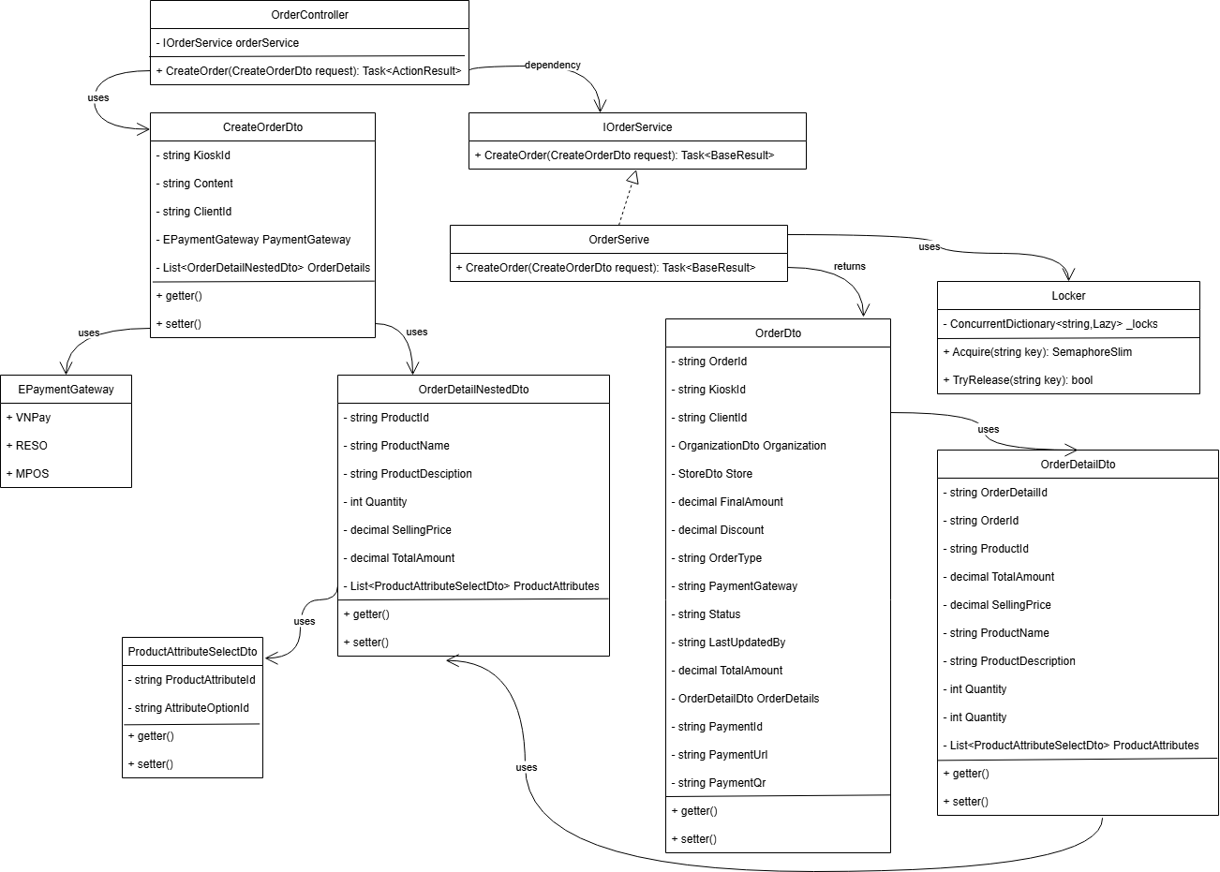

3.8.2 Sequence diagram
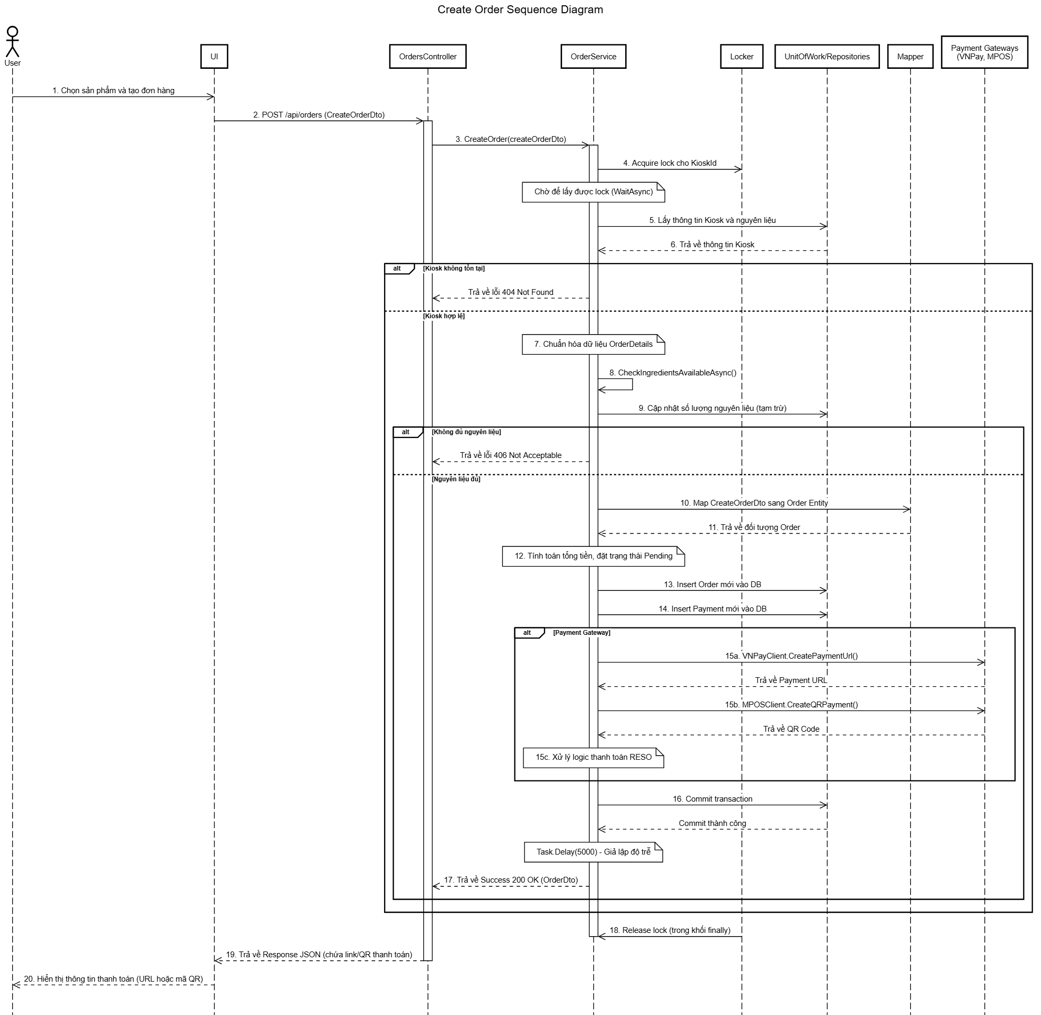

3.8.3 Class Specification

3.8.3.1 Order Controller Description Table
Figure 3.8.3.1 Order Controller Description Table
No | Method | Description
01 | Post(CreateOrderDto) | Receives an HTTP POST request to initiate the creation of a new order. It delegates the business logic processing to the IOrderService

3.8.3.2 Order Service Description Table
Figure 3.8.3.2 <name> Service Description Table
No | Method | Description
01 | CreateOrder(CreateOrderDto) | Orchestrates the entire order creation process. This involves calling other methods
02 | CheckIngredientsAvailableAsync() | An internal method to verify if there are enough ingredients in the Kiosk's inventory to fulfill the requested order
03 | Locker.Acquire(key) | Acquires a lock based on a unique key (KioskId) before processing
04 | Locker.Release() | releases lock after processing is complete to ensure data integrity
05 | Repositories.SingleOrDefaultAsync() | Retrieves a single entity (e.g., Kiosk) from the database that matches the specified criteria
06 | Repositories.UpdateRange() | Updates a collection of entities (e.g., DeviceIngredientState) in the database
07 | Repositories.InsertAsync() | Adds a new entity (e.g., Order, Payment) to the database
08 | Mapper.Map() | Transforms an object of one type (e.g., CreateOrderDto) into an object of another type (e.g., Order entity)
09 | PaymentGateways.CreatePaymentUrl() | Communicates with an external payment service (like VNPay or MPOS) to generate a payment URL or QR code
10 | UnitOfWork.CommitAsync() | Saves all changes made within the current transaction (inserts, updates) to the database permanently

3.8.3.2 Order DTOs Description Table
Figure 3.8.3.2 <name> DTOs Description Table
No | Method | Description
01 | CreateOrderDto | A Data Transfer Object used as input. It carries the new order's data from the client to the server, including order details, kiosk ID, and chosen payment method
02 | OrderDto | A Data Transfer Object used as output. It carries the created order's data from the server back to the client, including the new order ID and payment details (URL or QR code)

3.9 Process Order

3.9.1 Class Diagram
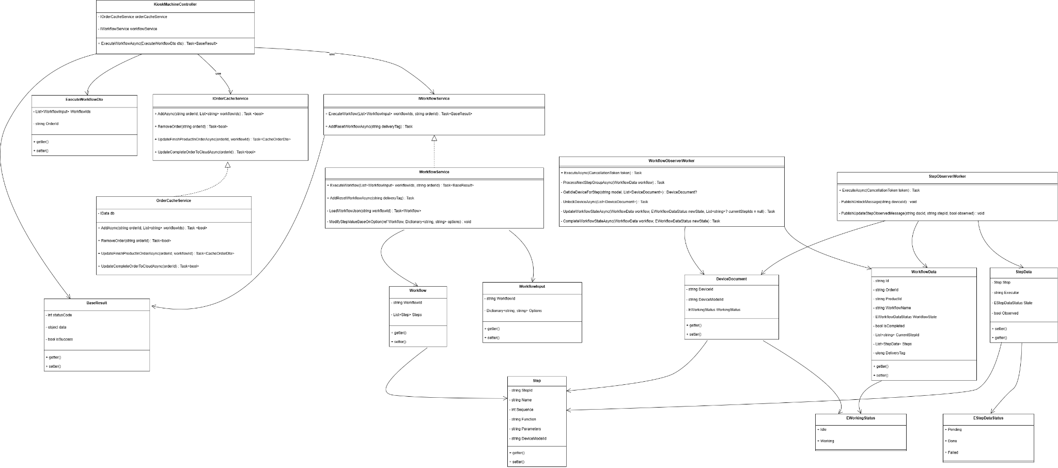

3.9.2 Sequence diagram
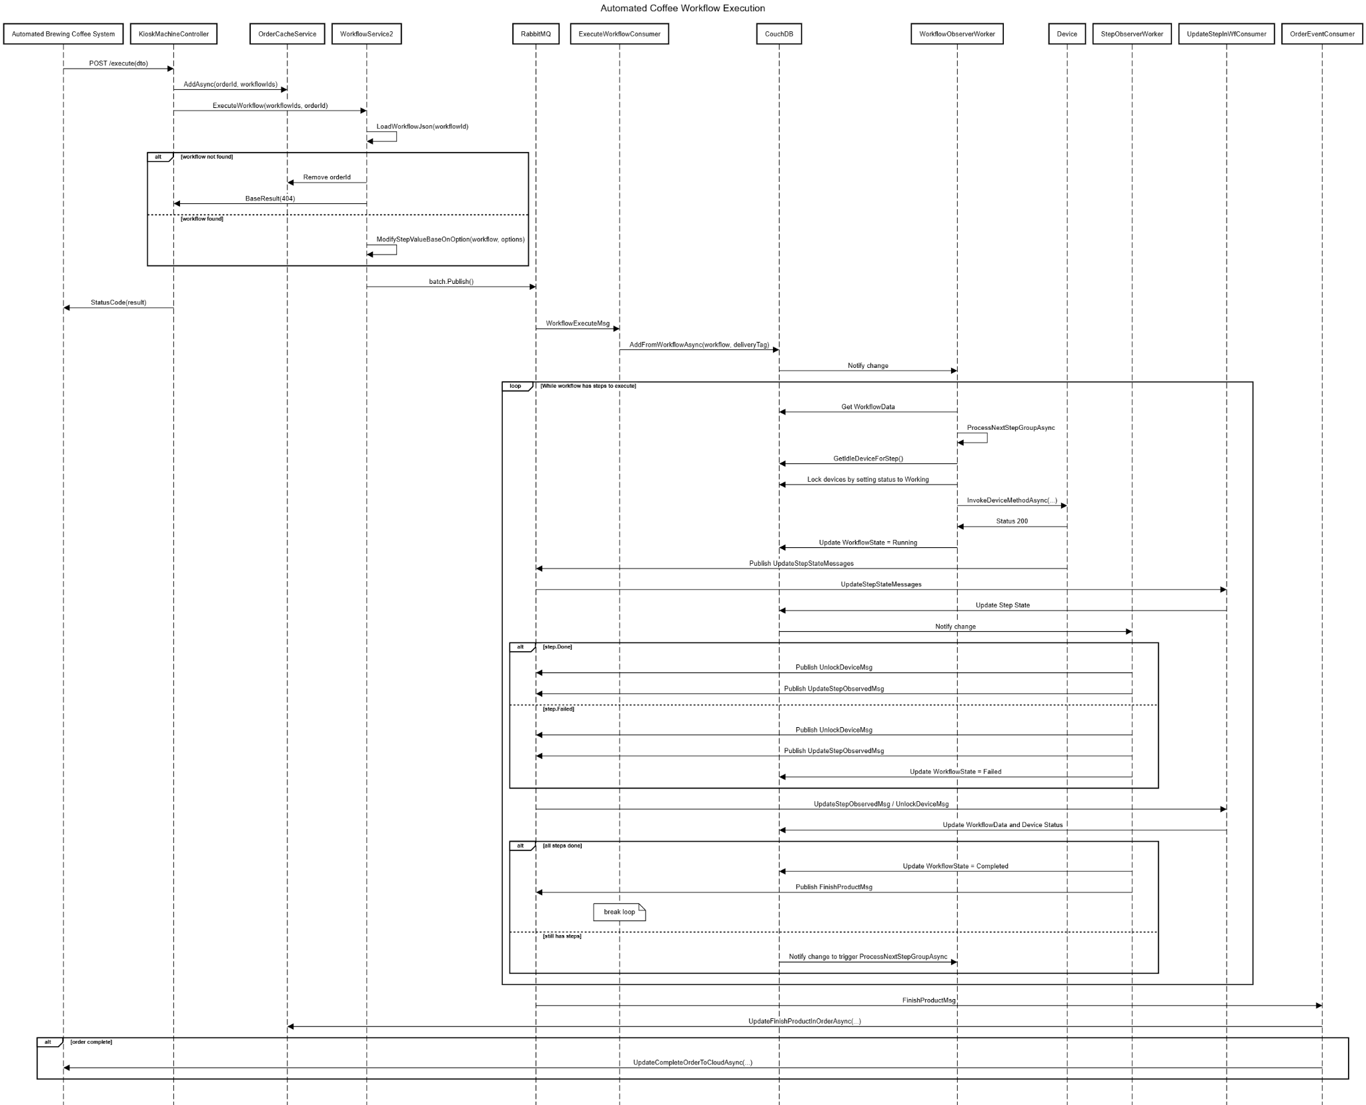

3.9.3 Class Specification

3.9.3.1 Kiosk Machine Controller Description Table
Figure 3.9.3.1 Kiosk Machine Controller Description Table
No | Method | Description
01 | ExecuteWorkflowAsync(ExecuteWorkflowDto dto) | Receives an order including a list of products, validates and modifies steps based on options, then calls the service layer to process the order.

3.9.3.2 OrderCacheService Description Table
Figure 3.9.3.2 OrderCacheService Description Table
No | Method | Description
01 | AddAsync(string orderId, List<string> workflowIds) | Caches for the given order.
02 | RemoveOrder(string orderId) | Marks a workflow as finished in the order.
03 | UpdateFinishProductInOrderAsync(orderId, workflowId) | Marks a workflow of a product as finished in the order.
04 | UpdateCompleteOrderToCloudAsync(orderId) | Update the order as complete and sync it to the cloud system.

3.9.3.3 WorkflowService Description Table
Figure 3.9.3.3 WorkflowService Description Table
No | Method | Description
01 | ExecuteWorkflow(List>WorkflowInput> workflowIds, string orderId) | Executes multiple workflows for a given order by pushing them to the queue.
02 | AddResetWorkflowAsync(string deliveryTag) | Executes default reset workflows.
03 | LoadWorkflowJson(string workflowId) | Locate and load the workflow saved as JSON from the folder.
04 | ModifyStepValueBaseOnOption(ref Workflow, Dictionary<string, string> options) | Updates step parameters in the workflow based on user-selected options.

3.9.3.4 Process Order DTOs Description Table
Figure 3.9.3.4 Process Order DTOs Description Table
No | Method | Description
01 | WorkflowInput | Used as input for specific workflows with customized options.
02 | Workflow | Represents a workflow reflected from the cloud system entity.
03 | Step | Each workflow has ordered steps; each step contains what action to run
04 | WorkflowData | Used during workflow execution to track step states and workflow progress.
05 | StepData | Each workflowData has ordered steps data; each step contains its state.
06 | DeviceDocument | Used for device locking and status tracking while processing the workflow.

3.10 Synchronous Kiosk Data

3.10.1 Class Diagram
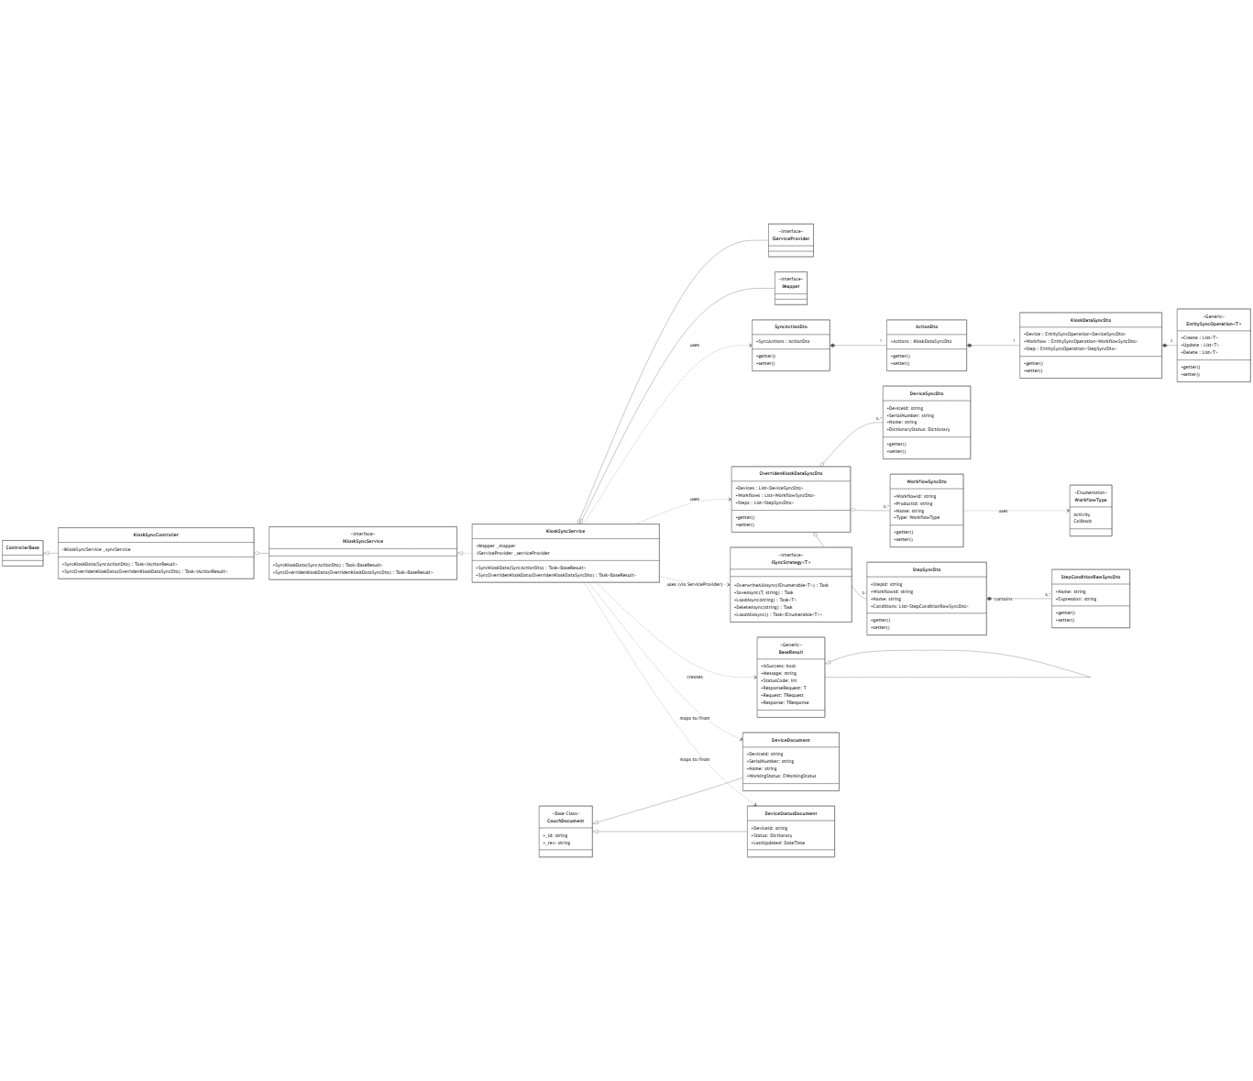

3.10.2 Sequence diagram
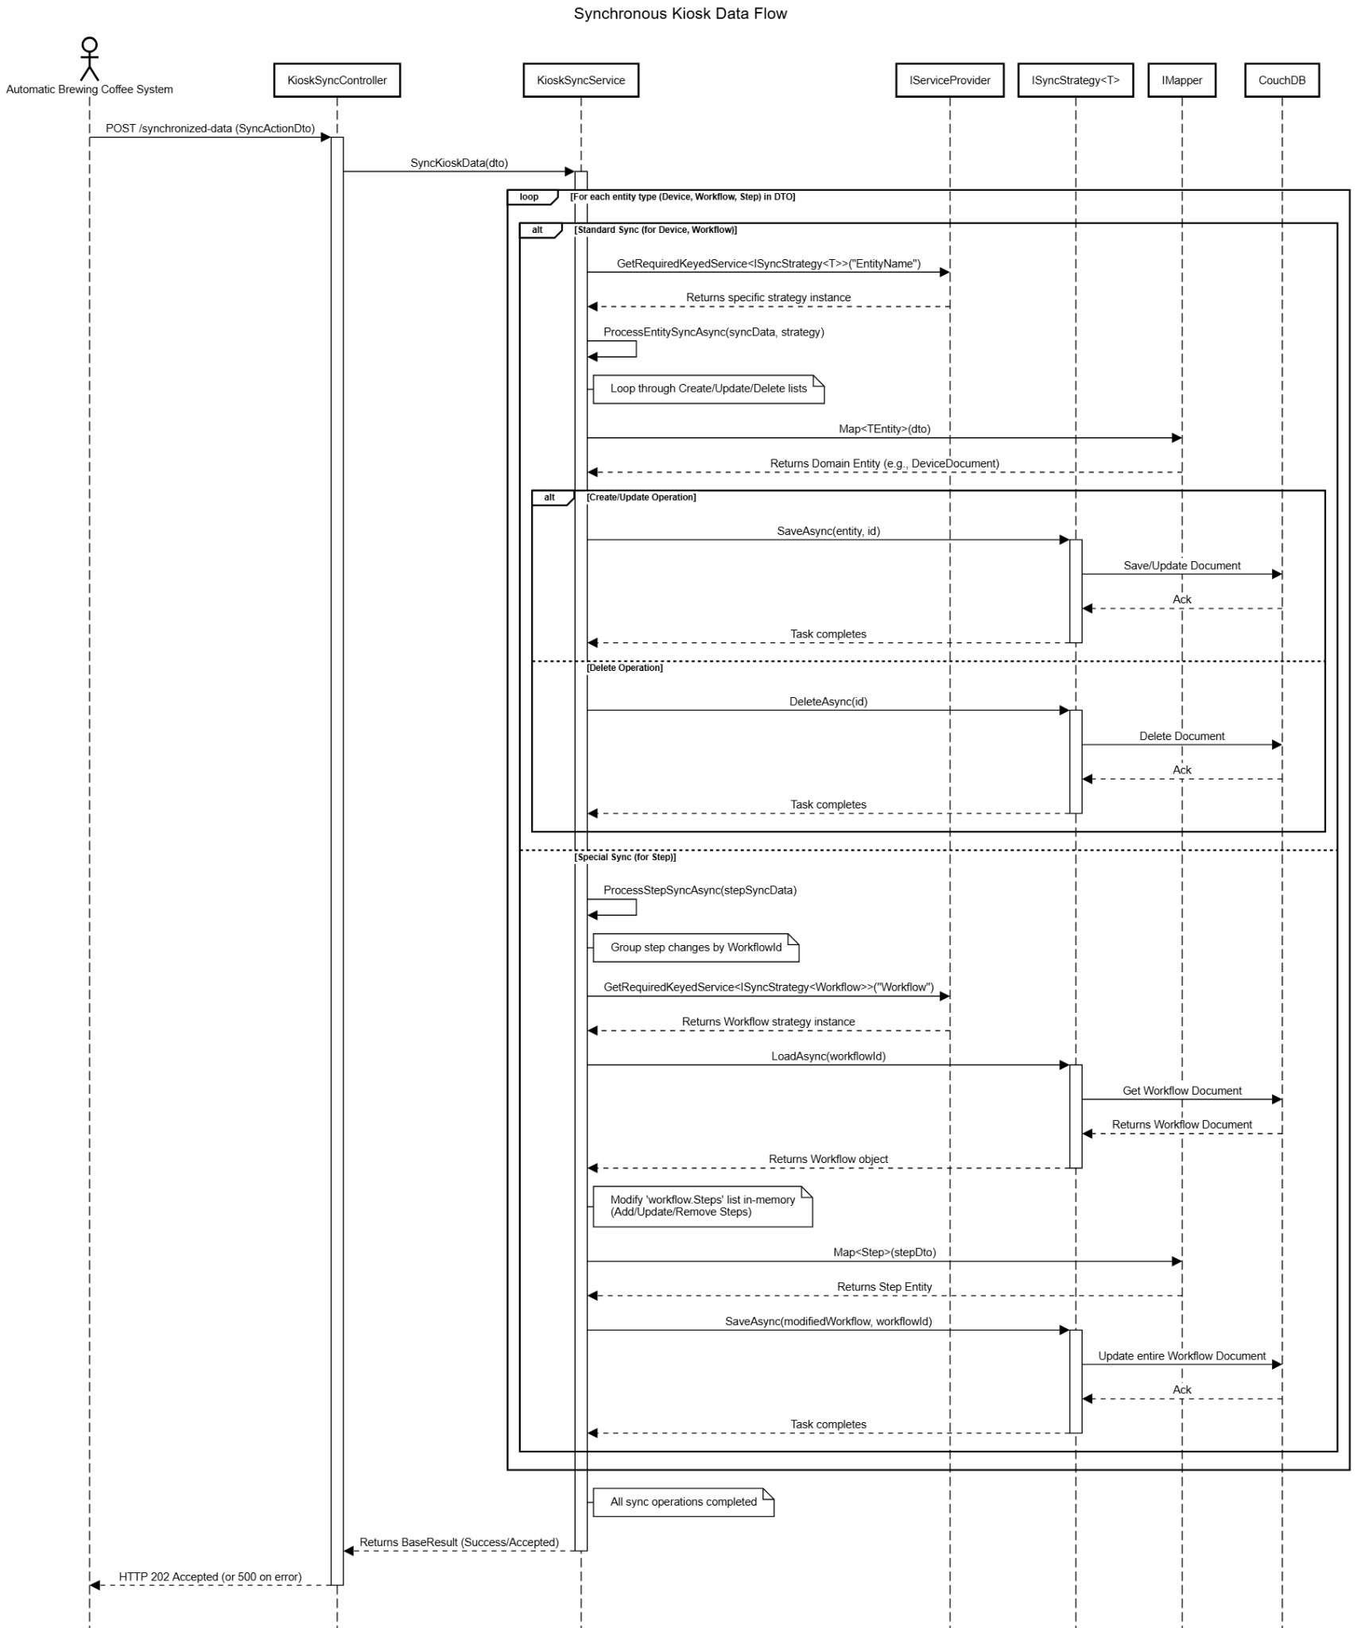

3.10.3 Class Specification

3.10.3.1 Kiosk Sync Controller Description Table
Figure 3.9.3.1 <name> Controller Description Table
No | Method | Description
01 | SyncKioskData(SyncActionDto dto) | Receives an HTTP POST request to perform an incremental data synchronization based on specific create, update, or delete actions
02 | SyncOverridenKioskData(OverridenKioskDataSyncDto dto) | Receives an HTTP POST request to perform a full data overwrite, replacing all existing kiosk data with the provided dataset

3.10.3.2 Kiosk Sync Service Description Table
Figure 3.9.3.2 <name> Service Description Table
No | Method | Description
01 | SyncKioskData(SyncActionDto request) | Orchestrates the incremental sync process by delegating entity-specific logic
02 | SyncOverridenKioskData(OverridenKioskDataSyncDto request) | Orchestrates the full data overwrite process by mapping DTOs to domain models and using the appropriate strategy's OverwriteAllAsync method to replace data in the database
03 | ProcessEntitySyncAsync<TDto, TEntity>(...) | A generic helper method that processes standard Create, Update, and Delete operations for any given entity type using its corresponding strategy
04 | ProcessStepSyncAsync(EntitySyncOperation<StepSyncDto> stepData) | A specialized helper method that handles the unique business logic for syncing Steps by loading the parent Workflow, modifying its internal Steps list, and saving the entire Workflow document

3.10.3.2 Kiosk Sync DTOs Description Table
Figure 3.9.3.2 <name> DTOs Description Table
No | Method | Description
01 | SyncActionDto, ActionDto, KioskDataSyncDto | A set of nested DTOs used to structure the incremental sync request, with KioskDataSyncDto holding the core CRUD operations
02 | EntitySyncOperation<T> | A generic DTO that defines the three possible action lists for an entity: Create, Update, and Delete
03 | OverridenKioskDataSyncDto | A DTO used for the full data overwrite request. It contains complete lists of all entities (a data snapshot) to replace existing data
04 | DeviceSyncDto, WorkflowSyncDto, StepSyncDto | DTOs that represent the data for individual entities (Device, Workflow, Step) being sent from the kiosk
05 | StepConditionRawSyncDto | A DTO that holds the data for a single condition belonging to a Step. It is nested within StepSyncDto
06 | BaseResult | A standard DTO used to encapsulate the result of a service operation, containing a success status, message, and status code

